**Higher Nationals - Summative Assignment Feedback Form**

|  |  |  |  |
| --- | --- | --- | --- |
| **Student Name/ID** | Mohamed Ansar Mohamed Riham  1028401 | | |
| **Unit Title** | Applied Programming and Design Principles | | |
| **Assignment Number** | Assignment 01 | **Assessor** | Ms. ALF. Sajeetha |
| **Submission Date** | 13.04.2025 | **Date Received 1st submission** |  |
| **Re-submission Date** |  | **Date Received 2nd submission** |  |
| **Assessor Feedback:**  *Please note that constructive and useful feedback should allow students to understand:   1. Strengths of performance 2. Limitations of performance 3. Any improvements needed in future assessments   Feedback should be against the learning outcomes and assessment criteria to help students understand how these inform the process of judging the overall grade.  Feedback should give full guidance to the students on how they have met the learning outcomes and assessment criteria. | | | |
| ***I certify that to the best of my knowledge the evidence submitted for this assignment is the student’s own. The student has clearly referenced any sources and any artificial intelligence (AI) tools used in the work. I have not solely used AI to grade the student’s work.*** | | | |
| **Grade:** | **Assessor Signature:** | | **Date:** |
| **Resubmission Feedback:**  *Please note resubmission feedback is focussed only on the resubmitted work | | | |
| **Grade:** | **Assessor Signature:** | | **Date:** |
| **Internal Verifier’s Comments:** | | | |
| **Signature & Date:** | | | |

* Please note that grade decisions are provisional. They are only confirmed once internal and external moderation has taken place and grades decisions have been agreed at the assessment board.

Pearson Education 2016

Higher Education Qualifications

Internal Verification of Assignment Brief

**Student Assessment Submission and Declaration**

When submitting evidence for assessment, each student must sign a declaration confirming that the work is their own.

|  |  |  |  |
| --- | --- | --- | --- |
| Student name:  **Mohamed Ansar Mohamed Riham** | | Assessor name: Ms. ALF. Sajeetha | |
| Issue date:  **26.02.2025** | Submission date:  **13.04.2025** | | Submitted on: |
| Programme:  **HND in Computing** | | | |
| Unit: **Programming** | | | |
| Assignment number and title: **Sales Data Analysis System for Sampath Food City (PVT) Ltd** | | | |

**Plagiarism**

Plagiarism is a particular form of cheating. Plagiarism must be avoided at all costs and students who break the rules, however innocently, may be penalised. It is your responsibility to ensure that you understand correct referencing practices. As a university level student, you are expected to use appropriate references throughout and keep carefully detailed notes of all your sources of materials for material you have used in your work, including any material downloaded from the Internet. Please consult the relevant unit lecturer or your course tutor if you need any further advice.

**Student Declaration**

|  |
| --- |
| **Student declaration**  I certify that the assignment submission is entirely my own work and I fully understand the consequences of plagiarism. I declare that the work submitted for assessment has been carried out without assistance other than that which is acceptable according to the rules of the specification. I certify I have clearly referenced any sources and any artificial intelligence (AI) tools used in the work. I understand that making a false declaration is a form of malpractice.  Student signature: Riham Date: 05 – 11 - 2025 |

|  |
| --- |
| **General Guidelines**   1. **A Cover page or title page – You should always attach a title page to your assignment. Use previous page as your cover sheet and make sure all the details are accurately filled.** 2. **Attach this brief as the first section of your assignment.** 3. **All the assignments should be prepared using a word processing software.** 4. **All the assignments should be printed on A4 sized papers. Use single side printing.** 5. **Allow 1” for top, bottom, right margins and 1.25” for the left margin of each page.**   **Word Processing Rules**   1. **The font size should be 12 poin, and should be in the style of Time New Roman.** 2. **Use 1.5 line spacing. Left justify all paragraphs.** 3. **Ensure that all the headings are consistent in terms of the font size and font style.** 4. **Use footer function in the word processor to insert Your Name, Subject, Assignment No, and Page Number on each page. This is useful if individual sheets become detached for any reason.** 5. **Use word processing application spell check and grammar check function to help editing your assignment.**   **Important Points**   1. **It is strictly prohibited to use text boxes to add texts in the assignments, except for the compulsory information. eg: Figures, tables of comparison etc. Adding text boxes in the body except for the before mentioned compulsory information will result in rejection of your work.** 2. **Avoid using page borders in your assignment body.** 3. **Carefully check the hand in date and the instructions given in the assignment. Late submissions will not be accepted.** 4. **Ensure that you give yourself enough time to complete the assignment by the due date.** 5. **Excuses of any nature will not be accepted for failure to hand in the work on time.** 6. **You must take responsibility for managing your own time effectively.** 7. **If you are unable to hand in your assignment on time and have valid reasons such as illness, you may apply (in writing) for an extension.** 8. **Failure to achieve at least PASS criteria will result in a REFERRAL grade.** 9. **Non-submission of work without valid reasons will lead to an automatic RE FERRAL. You will then be asked to complete an alternative assignment.** 10. **If you use other people’s work or ideas in your assignment, reference them properly using HARVARD referencing system to avoid plagiarism. You have to provide both in-text citation and a reference list.** 11. **If you are proven to be guilty of plagiarism or any academic misconduct, your grade could be reduced to A REFERRAL or at worst you could be expelled from the course.** |

**Unit 20: Applied Programming and Design Principles**

Assignment Brief

|  |  |
| --- | --- |
| **Programme Title** |  |
| Student Name/ID Number | Mohamed Ansar Mohamed Riham  1028401 |
| Unit Number and Title | Unit 20: Applied Programming and Design Principles |
| Academic Year | 2024 / 2025 |
| Unit Tutor | Ms. ALF. Sajeetha |
| Assignment Title | Sales Data Analysis System for Sampath Food City (PVT) Ltd |
| Issue Date | 26.02.2025 |
| Submission Date | 13.04.2025 |
| Submission Format | |
| The submission should be in the form of an individual report written in a concise, formal business style using single spacing and font size 12. You are required to make use of headings, paragraphs and subsections as appropriate, and all work must be supported with research and referenced using Harvard referencing system. Please also provide an end list of references using the Harvard referencing system.  **The recommended word count is 5,000–5,500 words for the report excluding annexures, although you will not be penalised for exceeding the total word limit.** | |
| Unit Learning Outcomes | |
| **LO1** Investigate the impact of SOLID development principles on the  OOP paradigm.  **LO2** Design a large dataset processing application using SOLID principles  and clean coding techniques  **LO3** Build a data processing application based on a developed design.  **LO4** Perform automatic testing on a data processing application. | |
| Transferable skills and competencies developed | |
|  | |
| **Vocational scenario** | |
| Sampath Food City (PVT) Ltd is a leading retail grocery shop located in Matugama, Sri Lanka with 5000 of customer base. It sells several grocery items to the customers such as bakery, beverage, pharmacy, meat, sea food and etc. Currently, a computerized application is used to handle day-to-day transactions of the shop and daily transaction data are stored in a centralized database. After every 6 months, the management team analyses the collected transaction data (sales data) of the shop to take some managerial decisions about the business. The current data analysis process is entirely manual. Therefore, several drawbacks and weaknesses are occurred in data analysis such as human bias, limited scope, time consuming, lack of usability, errors, high cost and lack of reproducibility. The top-level management of the shop has identified the need of a computer-based solution for the sales data analysis. Spera Labs (PVT) Ltd is a leading software development company in Sri Lanka and the top – level management of Sampath Food City (PVT) Ltd has given a contract to Spera Labs (PVT) to develop a computer-based application for sales data analysis. The top – level management of Sampath Food City (PVT) expects following results from the proposed **computer-based sales data analysis application**:   * **Best-selling products analysis**: Sales data can help identify the top-selling products in a supermarket. This information can be used to optimize inventory levels, ensure that popular products are always in stock, and improve overall sales. * **Product performance analysis**: Sales data can provide information about the performance of individual products over time. This information can be used to make informed decisions about product promotions, pricing, and placement. * **Customer behaviour analysis**: Sales data can provide insights into customer buying behaviour, such as which products customers tend to buy together (Pair Products), and which products are more likely to be purchased on specific days or at specific times of the year. * **Regional sales analysis**: provides the insights of the sales based on different regions (branches) of the supermarket network.   Imagine that you are a software engineer of Spera Labs (PVT) Ltd and you are assigned to develop the entire sales data analysis application. You should develop a standalone application (desktop application) and use “Python” as the programming language and “command line interface” as the user interfaces to develop the application. Several sample sales datasets are available in the following Google Drive location and you can use them for the application development.  <https://drive.google.com/drive/folders/1CtEq2zWI-1B2JWSCWlnpBH5p6gqBnZuG?usp=sharing> | |
| Assignment activity and guidance | |
| **PART 1**    **Prepare a report** by evaluating the impact of **SOLID** development principles on object-oriented application development. You should consider the following areas in preparing that report:  **Investigation** about Principles of **object-oriented paradigm, Class relationships** and Solid principles.  **Explanation** about **clean coding techniques** and the impact of clean coding techniques on the use of data structures and their operations in writing algorithms.  **Analysis** in different types of **design patterns** with examples.  **Evaluation** about the impact of solid development principles on object-oriented application development using appropriate examples.    **Part 2**  Prepare a design document to design a large dataset processing application for the given scenario. You should consider the following areas in preparing that document:  **Explanation** about utilization of solid principles, clean coding techniques and design patterns in the proposed application.  **Explanation** about how the design of the proposed application is refined to include multiple design patterns.  **Design** of the test plan (testing regime) for the proposed application by including a provision for automated testing.  **Part 3**  Build (develop) the proposed sales analysis application using Python programming language. Prepare a report by providing the screenshots of the source codes and user interfaces as **evidence** and **assessing** the effectiveness of using SOLID principles, clean coding techniques and programming patterns on the application developed.    **Part 4**  Perform automated testing on the developed application. You are required to prepare a report about that automated testing by considering following areas:  **Examination** about the different methods of implementing automatic testing as designed in the test plan.  **Screenshots** of the implemented automated testing as **evidence**.  **Discussion** about the differences between developer-produced and vendor-provided automatic testing tools for applications and software systems.  **Analysis** about the benefits and drawbacks of different forms of automatic testing of applications and software systems, with examples from the developed application. | |
| **Recommended Resources**  **Please note that the resources listed are examples for you to use as a starting point in your research – the list is not definitive.** | |

Contents

Introduction 5

Part 01: Report on SOLID Principles in OOP 5

1. Explanation of OOP Concepts (Encapsulation, Inheritance, Polymorphism, Abstraction) 5

1. Encapsulation 5

2. Inheritance 6

3. Polymorphism 6

4. Abstraction 7

2. Description of Class Relationships (Association, Aggregation, Composition) 8

1. Association 8

2. Aggregation 9

3. Composition 9

3. Discussion of The SOLID principles and their importance. 9

1. Single Responsibility Principle (SRP) 10

2. Open/Closed Principle (OCP) 10

3. Liskov Substitution Principle (LSP) 10

4. Interface Segregation Principle (ISP) 10

5. Dependency Inversion Principle (DIP) 10

4. Explanation of Clean Coding Techniques and How They Improve Data Structure and Algorithms 11

1. Clean Coding Techniques: 11

2. Impact on Data Structures and Algorithms: 13

5. Analysis of creational, structural, and behavioural design patterns with examples. 13

1. Creational Design Patterns 14

2. Structural Design Patterns 15

3. Behavioural Design Patterns 17

6. Evaluation of Impact of SOLID Principles on Real-World OOP Application Development 19

1. Increased Maintainability 19

2. Improved Extensibility 19

3. Increased Flexibility and Reusability 19

4. Simplified Interfaces 20

5. Looser Coupling and Better Testability 20

Real-World Impact 20

Part 02: Application Design Document 21

1. SOLID Principles Implementation (Oloruntoba & Walia, 2024) 21

2. Application Architecture 22

3. Integration of Design Pattern 22

4. Clean Coding Techniques 24

5. Test Plan and Automated Testing Strategies 24

6. Test Plan 25

• Content 25

1. Objectives 25

2. Objects to be tested 26

3. System Features 26

4. Testing Schedule 27

5. Tools Used for the Testing 27

Part 03: Development & Effectiveness Report 28

1. Application Overview 28

2. Development of the Python-Based Sales Analysis App 35

3. Assessment of SOLID Principles, Clean Code Practices, and Design Patterns 41

Clean Code Practices 43

Part 04: Automated Testing & Report 45

1. Objective: 45

2. Test Implementation: 45

Setup: 45

Unit Test Development: 45

Integration Testing: 46

System Testing: 46

User Acceptance Testing (UAT): 47

3. Test Results 50

Unit Test Results: 50

Integration Test Results: 51

System Test Results: 51

User Acceptance Testing (UAT): 51

Figure 1; output 6

Figure 2; Encapsulation example 7

Figure 3; Inheritance Example 7

Figure 4; Polymorphism Example 8

Figure 5; Abstraction Example 8

Figure 6; UML Diagram 9

Figure 7; Singleton Pattern 15

Figure 8; Factory Method Pattern 15

Figure 9; builder Pattern2 16

Figure 10; Builder Pattern 16

Figure 11; output 16

Figure 12; Adapter Pattern 17

Figure 13; Decorator Pattern 17

Figure 14; Facade Pattern 18

Figure 15; Observer Pattern 18

Figure 16; Strategy Pattern 19

Figure 17; Command Pattern 19

Figure 18; Application Architecture 23

Figure 19; class diagram 25

Figure 20; Home 30

Figure 21; Top Selling Products 30

Figure 22; Monthly Sales Trend 31

Figure 23; Regional Sales Analysis 31

Figure 24; Top 10 Frequent Customer (Total Spend) 32

Figure 25; Average Purchase Value per Customer 32

Figure 26; Customer Recency (Last Purchase Date) 33

Figure 27;Customer Purchase Frequency 33

Figure 28; Pruduct Search - Available Products 34

Figure 29; Search Specific Product 34

Figure 30; Regional Breakdown of the searched product 35

Figure 31; sales trend of searched product 35

Figure 32; pair product analysis 36

Figure 33; Data Ingesion Module 37

Figure 34; Data Processing Module 37

Figure 35; Data Storage Module 38

Figure 36; Data Storage Module 38

Figure 37; user interface module 1 39

Figure 38; user interface module 2 40

Figure 39; user interface module 3 41

Figure 40; user interface module 4 42

Figure 41; meaning full names 44

Figure 42; Logging 44

Figure 43; using try - except 45

Figure 44; comment 45

Figure 45; comment 45

Figure 46; comment; 45

Figure 47; docstring 45

Figure 48; docstring 45

Figure 49; Test Setup 46

Figure 50; Unit Test 47

Figure 51; Integration Testing 47

Figure 52; System testing 48

Figure 53; UAT Testing 49

Figure 54; UAT2 50

Figure 55; UAT3 50

Figure 56; UAT4 51

Figure 57; Test Results 51

Figure 58; Test 100% Success 51

Figure 59; CMD View of Test Results 52

Figure 60; User Acceptance Testing 53

Figure 61; Navigation Test 53

Figure 62; Upload CSV test 53

Figure 63; Data fetch Test 54

Figure 64;Search function test 54

Figure 65; Performance Testing 55

Table 1; Testing Schedule 28

Table 2; applied solid principle 42

Table 3; Clean code practices 43

Table 4; Use of design patterns 43

# Introduction

In modern software engineering, Object-Oriented Programming (OOP) is a central paradigm that centers on the organization of code into objects that contain both data and actions. OOP makes it easier to achieve higher modularity, reusability, and maintainability in software systems. To further enhance the object-oriented program's design and structure, the SOLID principles Single Responsibility, Open/Closed, Liskov Substitution (Liskov, 2018), Interface Segregation, and Dependency Inversion provide central guidelines. These principles collaborate towards achieving software that is robust, scalable, and maintainable.

# Part 01: Report on SOLID Principles in OOP

## Explanation of OOP Concepts (Encapsulation, Inheritance, Polymorphism, Abstraction)

### Encapsulation

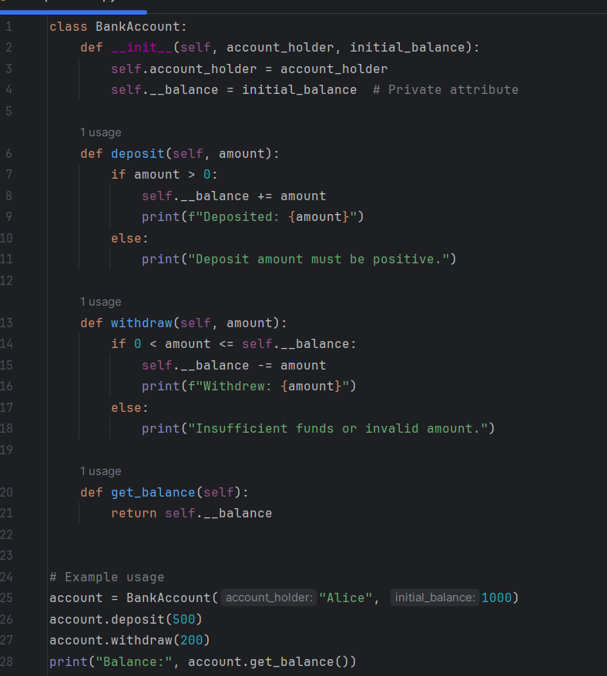Encapsulation is the bundling of data (attributes) and operations (methods or procedures) that operate upon the data together in one package, a class. It is a technique that prevents direct manipulation of some of an object's components, and this discourages unwanted interference and misuse of data. By enabling only necessary parts of an object to be visible through public methods, encapsulation enforces an controlled interface and hides the internal details.

#### Example:

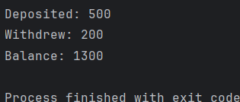In a bank system, one can have an Account class which encapsulates the balance and there are methods for deposit or withdraw. The balance is not directly accessed but it is accessed by the specified methods, maintaining data integrity (Anon., 2025).

Figure 1; output

Figure 2; Encapsulation example

### Inheritance

Inheritance allows a new class, referred to as a subclass or derived class, to inherit properties and operations of an already defined class, referred to as a superclass or base class. Inheritance promotes reusability of code and creates an inherited hierarchy of classes. The subclass can inherit and tailor the properties and behaviour of the superclass for some specifications.

#### Example:

Let's say there is a generic Vehicle class with attributes like speed and methods like *move()*. The Car class can inherit from Vehicle and add car-specific attributes like *number_of_doors* or overload the *move()* method to specify car-specific movement behaviour. (Anon., 2025)

Figure ; Inheritance Example

### Polymorphism

Polymorphism allows objects of different classes to be treated as objects of a common superclass. Polymorphism allows a single interface to specify different underlying structures (data types). The best and most common use of polymorphism is where a parent class reference is used to refer to a child class object, leading to dynamic method binding and more flexibility and integration of new features.

#### Example:

Figure 4; Polymorphism Example

If there is a Vehicle class with which Car and Bicycle classes share inheritance, then a method accepting an object of type Vehicle may accept an object of type Car or Bicycle and invoke the appropriate *move()* method on each subclass (Anon., 2025).

### Abstraction

Abstraction is all about making complex systems simple by expressing classes in a way that is appropriate to the problem. Abstraction is all about maintaining complex implementation details secret and showing only the salient features of the object. This concept helps reduce programming complexity and effort through the power of the programmer to focus on high-level interactions.

#### Example:

Figure 5; Abstraction Example

An abstract class Animal would have an abstract method *make_sound()*. The direct subclasses Dog and Cat would implement the method *make_sound()* to bark and meow, respectively. The abstraction is utilized in the code such that calls are made utilizing the interface of the Animal without paying attention to the specific type of animal. Segregation, and Dependency Inversion provide very important guidelines. All these principles strive to attain software that is more solid, extendable, and easy to manage (Anon., 2024).

**UML Diagram:**

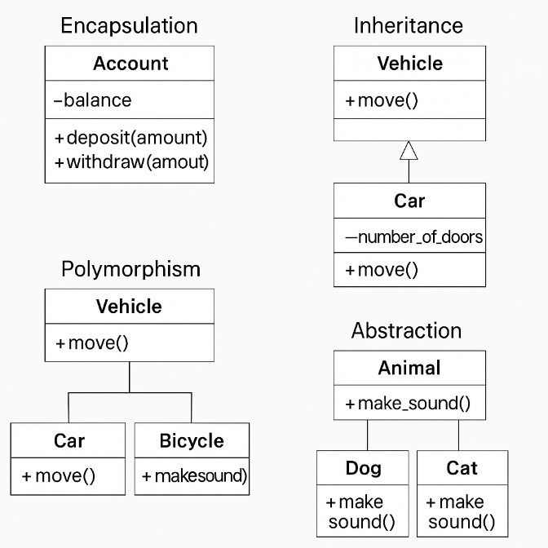

Figure ; UML Diagram

## Description of Class Relationships (Association, Aggregation, Composition)

In object-oriented programming, becoming fluent with the relationships between classes is imperative in order to create solid and maintainable systems. Class relationship types​ 3 class relationship types are association, aggregation, and composition. Each specifies a distinct class coupling, and dependency level.

### Association

Association is a general type of relationship between two independent classes, signifying that objects of one class are associated with objects of another. This relationship is not ownership and its objects can be made to exist independently. An association can be unidirectional or bidirectional, and can have many-to-one, one-to-many, or many-to-many multiplicities.

#### Example

For instance, Teacher class and a Student class can be an association, where a teacher can teach multiple students and a student can learn from multiple teachers. Teacher and Student classes could ultimately be developed on their own without the need for one another (Anon., 2024).

### Aggregation

Aggregation is a specific type of association that describes a "whole-part" relationship between the aggregate (whole) and its components. There is no dependency between the lifetime of the part and the whole in aggregation; the part is able to exists without the whole. This relation denotes a looser type of ownership.

#### Example

For instance, aggregation in object-oriented programming can exist between a Library class and a Book class wherein a library contains books, but a book can exist outside of a library. If they destroy the library, the books are still there (Anon., n.d.).

### Composition

Composition is a stronger kind of aggregation, that implies ownership and a dependent lifecycle. In a composition relationship, the part is also a whole in and of itself, but cannot exist without the whole it is part of, if the whole is destroyed, the parts are destroyed as well.

#### Example

Class Example: Let there be a House class and a Room class having a composition relation that a house is made of rooms. Once the rooms are gone, if the house is destroyed, then there is no house either (Anon., 2024).

## Discussion of The SOLID principles and their importance.

The SOLID principles are a set of five object-oriented programming design principles that assist in designing software that is more understandable, flexible, and maintainable. Robert C. Martin created the principles (Christian, 2021), which are a foundation of good software design.

### Single Responsibility Principle (SRP)

One class should have only one reason to change, or equivalently, one job or responsibility. Adhering to SRP makes the classes highly cohesive and hence the system more debuggable and maintainable. For example, having individual classes for user authentication and data processing makes it such that changes in one do not affect the other (TP, 2024).

### Open/Closed Principle (OCP)

Software objects should be open for extension but closed for modification. This encourages the extension of new features through inheritance or composition without modifying existing code and thus reducing the potential for introducing bugs. For instance, to accommodate a new form of payment, a new class can be created which extends the present payment processing feature without altering the original code (TP, 2024).

### Liskov Substitution Principle (LSP)

Instances of a superclass should be substitutable with instances of a subclass without compromising the program correctness. This maintains the derived classes extend the base classes without changing their expected behavior, preserving program correctness and allowing polymorphism. For example, a *Rectangle* class should be substitutable with a *Square* class without error, provided the *Square* class extends the behavior of *Rectangle* correctly (TP, 2024).

### Interface Segregation Principle (ISP)

No client should ever be forced to depend on mechanisms it does not use. This rule implies having distinct interfaces for different clients, removing unnecessary coupling and dependencies. For example, rather than a broad *VehicleInterface* with *drive*, *fly*, and *sail* methods, having distinct interfaces like *Drivable*, *Flyable*, and *Sailable* avoids classes implementing methods they do not need (TP, 2024).

### Dependency Inversion Principle (DIP)

High-level modules should never depend on low-level modules; they both should depend on abstractions. This makes components separate so that the system can be more flexible and easier to maintain. For example, a *NotificationService* should depend on an interface *INotificationSender* rather than on concrete ones like *EmailSender* or *SMSSender* so that the service can use any type of notification without changing code (TP, 2024).

By integrating these principles into the software development process, applications are more flexible, modular, and resilient and lead to more understandable systems that are simpler to test and maintain.

## Explanation of Clean Coding Techniques and How They Improve Data Structure and Algorithms

Clean coding practices are essential software development practices that emphasize coding that is readable, maintainable, and efficient. Developers can make data structures and algorithms more understandable and effective by adhering to these principles, leading to improved and scalable applications.​

### Clean Coding Techniques:

1. **Meaningful Naming Conventions:**

* Descriptive Identifiers: Use descriptive and clear names for variables, functions, classes, and other identifiers to effectively communicate their purpose. Avoid using ambiguous or single-letter names. For example, instead of giving a variable name **x**, use **total_score** to define its purpose (MARK, 2023).

1. **Modular Design:**

* Single Responsibility Principle (SRP): Ensure that every class or function handles only one, specific task or responsibility. With this modular approach, debugging and testing are simpler since each component works independently.
* Encapsulation: Bundle associated data and methods within a class to hide internal implementation details and expose only necessary interfaces. Encapsulation enhances data integrity and minimizes dependencies (Ganglani, 2023).

1. **Consistent Formatting and Structure:**

* Indentation and Spacing: Employ consistent indentation and spacing throughout the codebase to improve readability. Well-structured code facilitates developers to understand the structure and flow of the program more easily (Savvyprogrmr, 2023).
* Maximum Line Length: Limit line lengths of code to a maximum of a reasonable number of characters (usually 80 to 120) to prevent horizontal scrolling and improve readability.

1. **Effective Comments and Documentation:**

* Purposeful Comments: Reserve comments explaining the 'why' behind less obvious or complex bits of code, rather than merely the obvious ones. This facilitates an easier understanding of the rationale behind some specific implementations.
* Avoid Redundancy: Do not include comments that are merely copies of the code. Instead, try to provide insight or explanation not immediately apparent from the code.​

1. **Error Handling and Exception Management:**

* Graceful Degradation: Implement effective error handling so that the application is able to handle unexpected situations without freezing. Using try-catch blocks or equivalent mechanisms helps to catch and handle exceptions effectively.
* Resource Management: Ensure that resources such as file handles or database connections are released upon usage, typically by employing finally blocks or resource management utilities.​

1. **Refactoring and Continuous Improvement:**

* Iterative Enhancement: Occasionally return to and refine code to make it more structurally sound and efficient without altering its external behavior. Refactoring helps eliminate code smells and technical debt.
* Eliminate Redundancies: Identify and remove repetitive code or redundant complexities to streamline the codebase and simplify it for easier maintenance. This streamlines the code and makes it simpler to maintain.​

### Impact on Data Structures and Algorithms:

Adopting clean coding techniques on data structures and algorithms brings:

* **Improved Readability**: Simple and structured code helps developers better understand and follow the logic of data structures and algorithms, facilitating teamwork and knowledge transfer.
* **Improved Maintainability**: Modular and commented code facilitates easier updates or changes to data structures and algorithms, reducing the likelihood of error injection in maintenance.​
* **Improved Performance**: Thorough data structure and algorithm design and coding, adhering to clean coding principles, can lead to more efficient and superior-performing solutions.
* **Reduced Error Rate**: Proper error handling and organized code decrease the chances of bugs and enable easier debugging if bugs are present.​

By embracing clean coding practices, developers can create data structures and algorithms that not only work well but are also maintainable and flexible enough to handle future requirements.

## Analysis of creational, structural, and behavioural design patterns with examples.

Design patterns are established solutions to common problems that occur while designing software. They are categorized into three broad types: creational, structural, and behavioral patterns. Each type addresses particular problems of software development, promoting code reusability, maintainability, and scalability.

### 1. Creational Design Patterns

Creational patterns focus on the mechanism of object creation, abstracting the creation process to enhance flexibility and reusability. They help to make a system independent of how its objects are created, composed, and represented (Anon., 2025) (Anon., 2024).

* 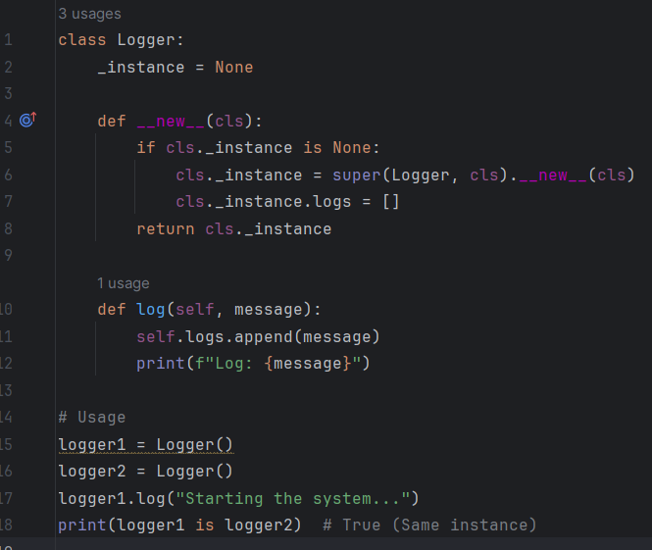**Singleton Pattern**: Ensures that there is a single instance of a class and provides a global point of access to it. This is extremely useful with handling shared resources, such as a configuration object or a connection pool.

Figure ; Singleton Pattern

* ***Example***: A logging class that logs to a file. Through the use of the Singleton pattern, the application ensures that the entire section of the application shares the same logger instance so that concurrent access issues do not occur.
* 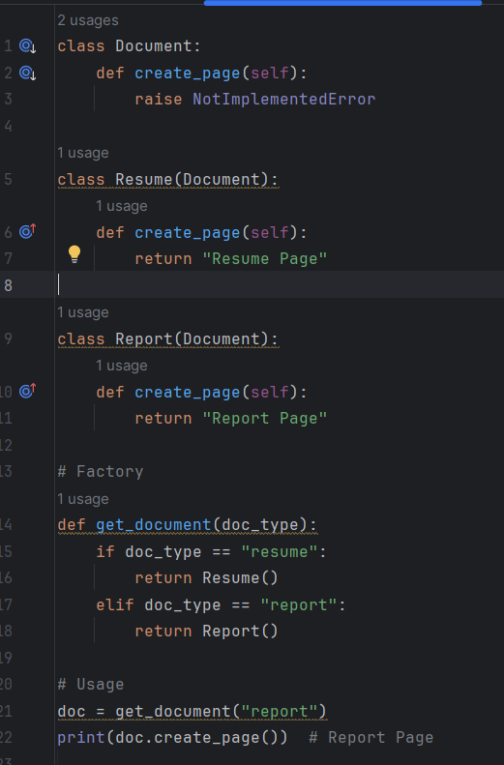**Factory Method Pattern**: Defines an interface for creating an object but allows subclasses to override the type of objects to be created. This supports loose coupling between client classes and the classes they create.

Figure ; Factory Method Pattern

* ***Example***: A base Document class for a document management system can contain a factory method createPage(). The subclasses like Resume and Report override this method to build specific types of pages.
* 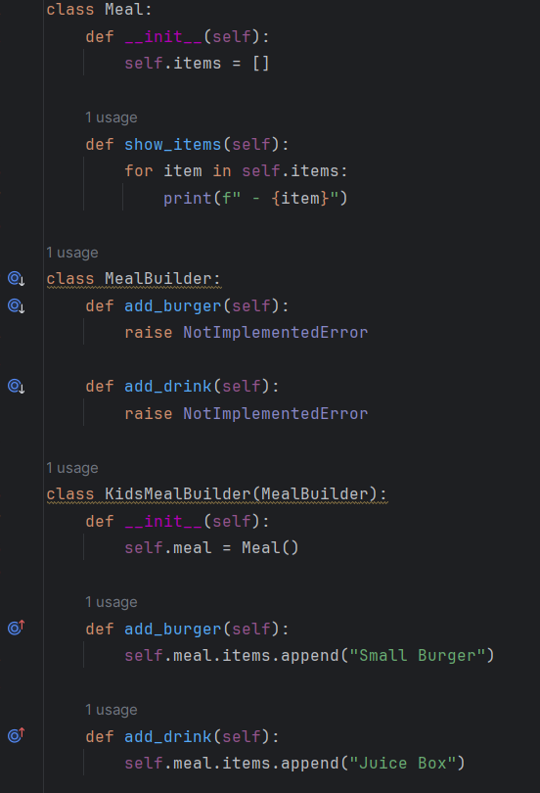**Builder Pattern**: This pattern separates the building process of an intricate object from its representation in a way that the same construction process can give rise to varied representations. This pattern is useful when an object contains numerous optional components or settings.
* **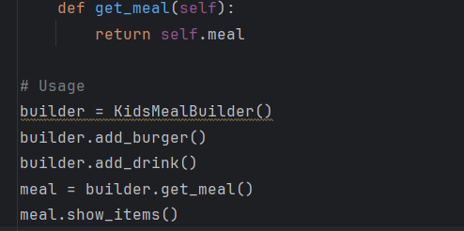*Example***: Constructing a Meal object in a fast-food restaurant application. The builder can construct a meal with various items like a burger, drink, and toy, depending on what the customer ordered.​

Figure ; builder Pattern2

Figure ; Builder Pattern

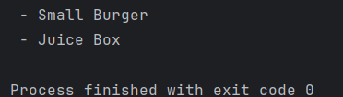

Figure 11; output

### 2. Structural Design Patterns

Structural patterns are all about object composition, meaning that when one element of a system is modified, the entire system does not need to change with it. They help to ensure that different elements of a system work together in harmony.

* 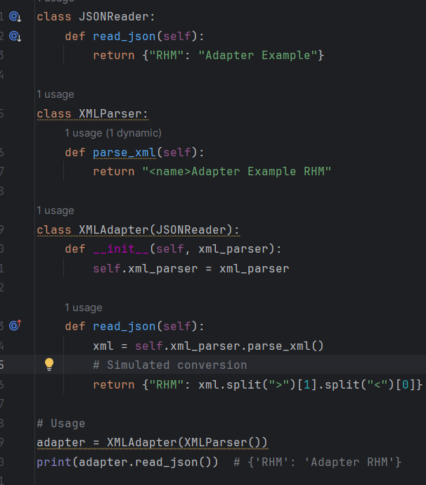**Adapter Pattern**: Allowing incompatible interfaces to work together by converting a class interface into another interface that a client needs. It's often used to allow existing classes to be used with other classes without their source code modification.
* ***Use Case***: A program that needs to read data from XML and JSON files. A JSON file can be made ready for processing by the program using an existing XML parsing infrastructure by creating an adapter.

Figure ; Adapter Pattern

* 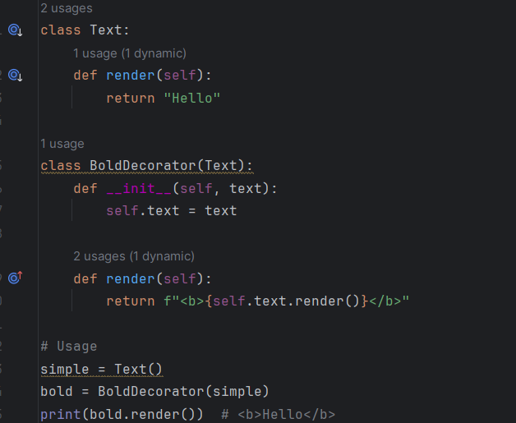**Decorator Pattern**: Facilitates the addition of new behavior to objects in a very flexible way without subclassing. It's an alternative to extending functionality and allows flexibility in extending the same.

Figure ; Decorator Pattern

* ***Example***: A text editor application where the text is displayed in different styles like bold, italic, or underline. Decorators can be applied at runtime to attach these styles to text objects.
* 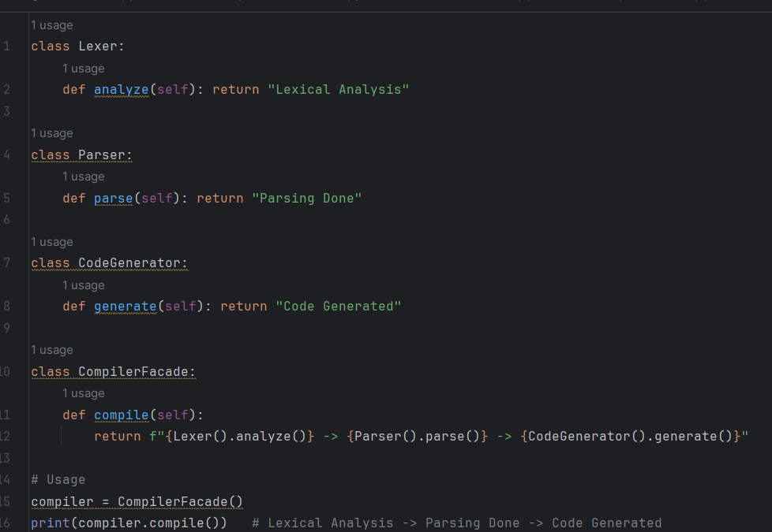**Facade Pattern**: Provides a straightforward interface to a massive code base, for example, a complex subsystem. It keeps the client separate from the subsystem and simplifies the usage and reduces dependencies. (Anon., 2013)​

Figure ; Facade Pattern

* ***Example***: A compiler system with a number of subsystems like lexical analysis, parsing, and code generation. A facade can provide one interface to these subsystems, simplifying the compilation process for clients.​

### 3. Behavioural Design Patterns

Behavioural patterns are all about communication between objects such that objects are loosely coupled and are able to communicate flexibly and extendible (Anon., 2013) (Smith, 2016) (McBurney, n.d.).

* 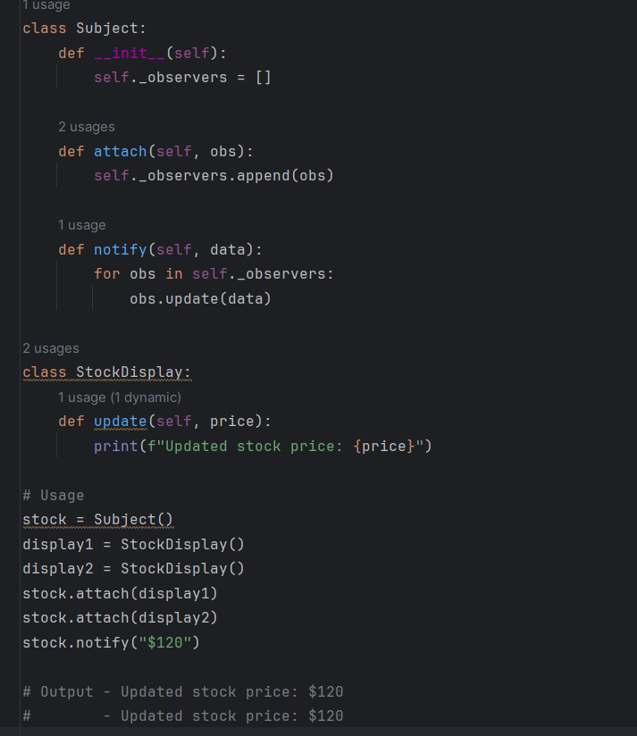**Observer Pattern**: Creates a one-to-many dependency between objects such that if one object changes state, all its dependents are notified and updated automatically. It is used extensively in event handling systems.
* ***Example***: A stock broker program where multiple display objects (observers) need to be updated in real time whenever the stock prices (subject) are modified.

Figure ; Observer Pattern

* 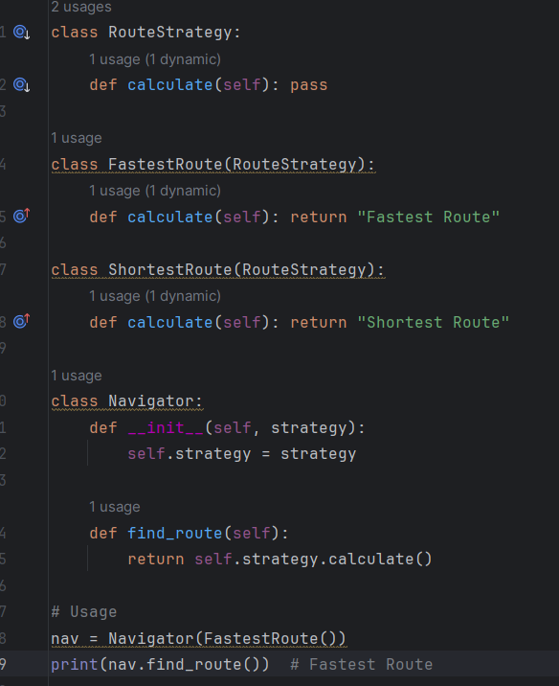**Strategy Pattern**: Binds an algorithm to a client by passing a parameter that represents this algorithm, which makes the algorithm independent of the clients that use it (Anon., 2013).

Figure ; Strategy Pattern

* ***Example***: A navigation application which can calculate routes with different strategies such as shortest distance, fastest time or no tolls. Every strategy may be encapsulated and traded on demand.
* 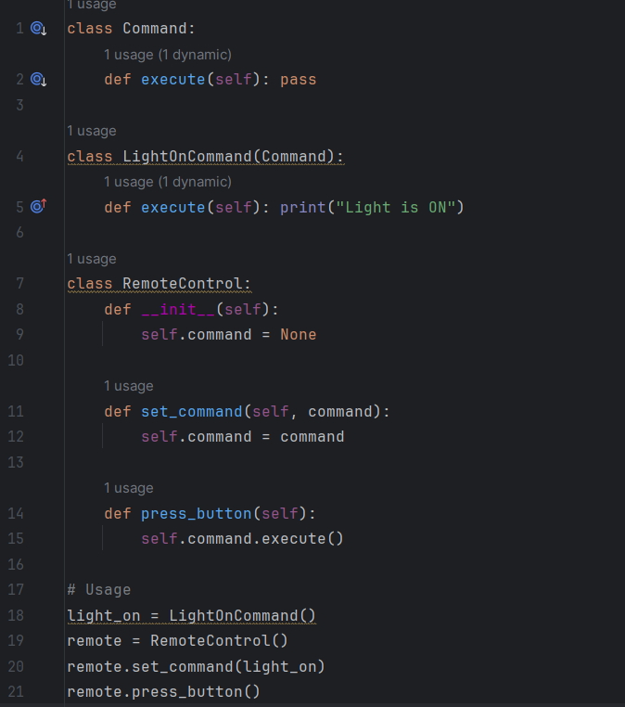**Command Pattern**: It encapsulates a request as an object, hence allowing users to parameterize clients with queues, requests, and operations. It also provides facilities for undoable operations.

Figure ; Command Pattern

* ***Example***: A remote control program where each button press is encapsulated as a command object, allowing simple assignment of actions and undoing of operations.

By learning and applying these design patterns, software developers are able to architect systems that are more modular, easier to maintain, and more suited to change

## Evaluation of Impact of SOLID Principles on Real-World OOP Application Development

The SOLID principles—Single Responsibility, Open-Closed, Liskov Substitution, Interface Segregation, and Dependency Inversion—are fundamental object-oriented programming (OOP) best practices employed to create software that is maintainable, scalable, and robust. Their application has implications on the creation of real-world OOP applications in some critical domains: (Anon., 2025) (Oloruntoba & Walia, 2024) (Anon., 2025) (Anon., n.d.) (Anon., 2013)

### Increased Maintainability

By adhering to the Single Responsibility Principle (SRP), programmers ensure that each class only does one specific thing. With this highly targeted approach, debugging and maintenance are simpler as modifications to a single functionality are limited to a single class. The potential for unforeseen side effects elsewhere in the program is thus diminished, leading to maintainable codebases.

### Improved Extensibility

The Open-Closed Principle (OCP) supports software entities being open for extension but closed for modification. This means that code already developed can be extended to accommodate new features without altering its existing form. The application of OCP supports features, such as more payment methods in an online shopping site, being added through the addition of new classes that extend from the existing ones, hence the integrity of the original code being preserved. (Anon., n.d.) (Anon., 2025)

### Increased Flexibility and Reusability

Liskov Substitution Principle (LSP) ensures that one can replace an instance of a superclass with a subclass instance without changing the program's correctness. LSP aids polymorphic behavior, which promotes more reusable and flexible code. For instance, in a graphing program, a procedure for drawing shapes might function flawlessly with any shape inherited from some general Shape superclass, whether Circle, Square, or Triangle (Anon., n.d.). (Anon., 2025)

### Simplified Interfaces

The Interface Segregation Principle (ISP) promotes the use of specialized, client-specific interfaces rather than a single, universal interface. This type of design avoids forcing classes to implement methods that are irrelevant to them, creating a more modular and comprehensible system. For example, in a multi-functional printer system, separate interfaces for Printing, Scanning, and Faxing avoid a basic printer class from having to implement faxing capabilities unnecessarily (Anon., 2025).​

### Looser Coupling and Better Testability

The Dependency Inversion Principle (DIP) recommends that developers should depend on abstractions rather than concrete classes. By injecting dependencies into classes, applications create a looser coupling between components, with more flexibility and simpler unit testing. For example, a data access layer based on an abstract database interface can talk to various database implementations without changing the business logic (Anon., 2025).

### Real-World Impact

Applying SOLID principles to practical OOP development leads to more understandable, modifiable, and extendable software systems. They enable modular development where the units can be developed, tested, and deployed independently, promoting agile development models and continuous integration. However, rigid constraint enforcement requires careful design consideration and may introduce higher complexity. Developers should balance the benefits of SOLID principles with specific needs and constraints of their projects to achieve optimal outcomes.​

Finally, the SOLID principles are a set of instructions for developers seeking to create good-quality object-oriented software. The judicious application of them enhances code maintainability, flexibility, and scalability to produce software systems that can sustain evolving requirements and technologies.

# Part 02: Application Design Document

Constructing a large-scale dataset processing application requires a structured process involving SOLID principles, clean code principles, and a number of design patterns that are utilized in order to enhance scalability, maintainability, and performance. Below is the architecture for an application at large scale with explanations on how SOLID principles are to be applied, including design patterns like Singleton, Factory, and Observer, and presents a test plan with elaborate automated methods of testing.

## SOLID Principles Implementation (Oloruntoba & Walia, 2024)

1. Single Responsibility Principle (SRP)

* Each class has a single responsibility.
* Example: A ***UserService*** class handles user operations, and a separate ***LoggerService*** handles logging.

1. Open/Closed Principle (OCP)

* The system is open for extension but closed for modification.
* Example: Using a ***PaymentProcessor*** base class that allows new payment methods without modifying existing code.

1. Liskov Substitution Principle (LSP)

* Subclasses should be interchangeable with their parent classes.
* Example: A ***CreditCardPayment*** and ***PayPalPayment*** class both inherit from ***PaymentProcessor***.

1. Interface Segregation Principle (ISP)

* Clients should not depend on interfaces they don’t use.
* Example: Separate interfaces for ***EmailNotification*** and ***SMSNotification*** instead of a single ***Notification*** interface.

1. Dependency Inversion Principle (DIP)

* High-level modules should not depend on low-level modules.
* Example: Using dependency injection to inject database services into the ***UserService***.

## Application Architecture

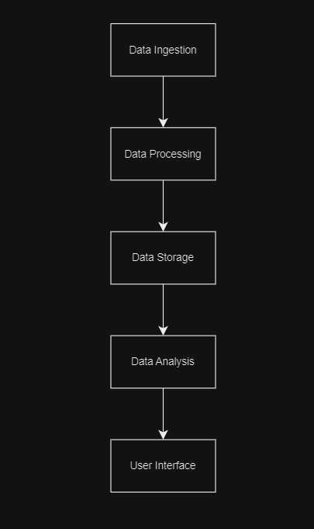

Figure 18; Application Architecture

The app is divided into distinct modules, each of which adheres to the Single Responsibility Principle (SRP) to promote modularity and maintainability:

* **Data Ingestion Module**: Takes care of retrieving data from source in such a manner that is accurate and efficient to bring into the system.
* **Data Processing Module**: Performs transformations, validations, and calculations on the ingested data to make it available for analysis.
* **Data Storage Module**: The module stores the processed data, providing for quick retrieval and preserving data integrity.​
* **Data Analysis Module**: The module performs analysis operations on the processed data to gain meaningful information.​
* **User Interface Module**: Provides user interfaces to enable users to interface with the application, including data visualization and reporting capabilities.

Every module is designed to be open for extension but closed for modification, in accordance with the Open/Closed Principle (OCP) (Chris, 2023). Such a design allows for adding new functionality without modifying existing code, enhancing the extensibility of the application.​

## Integration of Design Pattern

In order to address specific concerns regarding the processing of massive amounts of data, the following design patterns are employed:

* **Singleton Pattern**: Ensures there's a single instance of a class and the same can be accessed everywhere in the application. It's useful in case of shared resources like database connections or config values (Anon., 2025).​
* *Usage*: A Singleton pattern in the Data Storage Module could be employed in managing a single instance of database connection pool to avoid the overconsumption of the resources by opening multiple connections unnecessarily.
* **Factory Pattern**: Provides a superclass with an interface for object creation but allows subclasses to alter the type of objects to be created. It promotes flexibility and scalability in the management of multiple data sources (Tutorialspoint, n.d.).
* *Implementation*: Factory pattern can be used in the Data Ingestion Module to produce appropriate data source handlers based on the data source type (CSV) so that the system is able to manage data easily.
* **Observer Pattern**: Defines a one-to-many dependency between objects such that when one object changes state, all its dependents are notified and updated automatically. This ensures that all parts of the application are kept in sync and up to date. (Anon., 2025)
* *Implementation*: In the Data Analysis Module, the Observer pattern can be used to notify various components (e.g., user interface, reporting tools) whenever new analysis results are available, so that all dependent components are notified of the current data.​

With the integration of these design patterns, the application receives a flexible and manageable architecture that can look after the complexities associated with big-data processing.​

Here I created class diagram for the designed application.

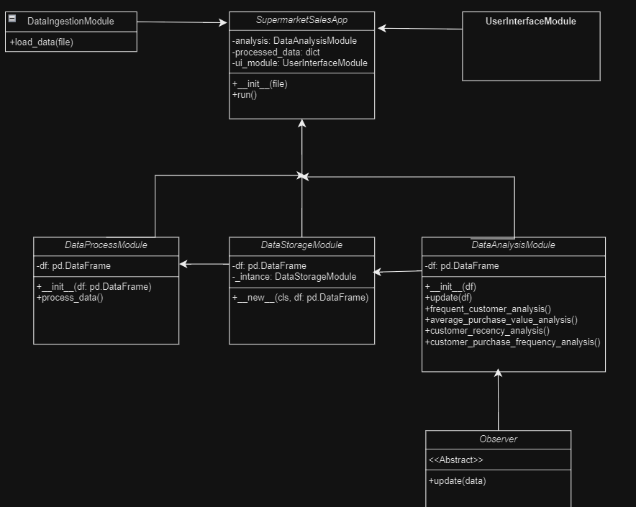

Figure ; class diagram

## Clean Coding Techniques

The application employs clean coding practices to enhance readability and maintainability: (Anon., 2024)

* **Meaningful Naming Conventions**: Variables, functions, and classes are named in a manner that explains their function.​
* **Consistent Formatting**: Adhering to a consistent coding style throughout the codebase to make it easier to read.​
* **Comprehensive Documentation**: Inline comments and external documentation provide clear explanations of intricate logic and system architecture.
* **Modular Design**: The code is segregated into small, manageable functions and classes with one functionality each, which is easier to test and debug.

These principles result in a code base that is easier to understand, alter, and add extensions to, abiding by the principles of clean code.

## Test Plan and Automated Testing Strategies

A strict testing schedule is implemented to ensure the reliability and performance of the application:

* **Unit Testing**: Unit tests are performed for each module to test individual pieces. Automated test suites are utilized to run the tests repetitively.
* **Integration Testing**: Integration tests are run to ensure multiple modules interact appropriately, and data flows properly within the system.
* **Performance Testing**: The application is tested with a load test to measure its performance in different situations to ensure that it can work efficiently with big data.
* **Automated Testing Tools**: Automated tests are executed using tools such as pytest and unittest, which provide real-time feedback about code changes and enable continuous integration.
* **Test Data Management**: Automated test data is generated to run tests on representative and diverse datasets, resulting in improved test coverage.

With the combination of these testing methods, the application meets stringent levels of reliability and performance, crucial for efficient processing of big datasets.

In summary, the proposed application design employs SOLID principles, clean coding strategies, and thoughtful design patterns to construct a sustainable and scalable system for handling extensive data sets at a high efficiency level. The robust testing approach, emphasized automation, guarantees the application is sturdy and dependable across its lifespan.

## Test Plan

### Content

* Objectives
* Objects to be tested
* System features
* Schedule of the testing
* Tools used for the testing

### Objectives

To ensure that the sales analysis application built works as expected, performs well with big data, and gives accurate analytical insights such as best-selling products, customer behavior, and product performance. Testing will also confirm adherence to SOLID principles, clean code, and design patterns.

### Objects to be tested

* Best-selling product analysis
* Analysis of customer behavior
* Analysis of product performance
* Analysis of regional sales

### System Features

#### Hardware Requirements

* RAM: 4GB minimum (8GB recommended)
* Hard Disk: 500MB minimum free space (for datasets and logs)
* Processor: Intel Core i3 or higher (multi-core recommended for faster data processing)

#### Software Requirements

* **Operating System**: Windows 10 / Windows 11 / Linux / macOS
* **Python IDE**: VS Code / PyCharm / Jupyter Notebook / IDLE
* **Python Packages and Libraries**:
* pandas (data manipulation)
* numpy (numerical operations)
* matplotlib, seaborn (visualizations)
* scikit-learn (if any ML is used)
* unittest or pytest (for automated testing)
* csv or openpyxl (file handling)

#### My System Configuration

* **RAM**: 16GB
* **SSD**: 1TB
* **HDD**: 1TB
* **Processor**: Intel Core i5 1135G7 – it has a better processing power than current gen i3 processors and also it has a powerful integrated graphics (**Intel IrisXe Graphics**). If needed I can use the graphics power for faster processing.
* **Operating System**: Windows 10
* **Python IDE**: PyCharm

### Testing Schedule

Table ; Testing Schedule

|  |  |  |
| --- | --- | --- |
| Tasks | Start Date | End Date |
| Unit Test Development | 2025-03-20 | 2025-03-22 |
| Integration Testing | 2025-03-22 | 2025-03-23 |
| System Testing | 2025-03-23 | 2025-03-25 |
| User Acceptancy Testing | 2025-03-26 | 2025-03-28 |
| Finalizing and fixing bugs | 2025-03-28 | 2025-03-31 |

### Tools Used for the Testing

* Python Libraries for Data Processing, Analysis and Unit Testing:
* pandas, numpy, matplotlib, seaborn, csv, openpyxl
* unittest, pytest for unit and integration testing

# Part 03: Development & Effectiveness Report

## Application Overview

The tool for sales analysis was implemented using Python and the Streamlit library to provide a user-friendly, interactive dashboard. The tool provides users with an option to upload a CSV file and explore various insights such as:

I have used 3 different datasets. First is the dataset given by the lecturer which has low data amount(500rows). After that I have generated some of the data using an AI tool which is the second dataset (10 000rows). And then I tried to get more data and get it, which has 100 000rows.

Here is the demonstration video of the Created Application. I have uploaded on YouTube: <https://youtu.be/Ct4KMro4JqU>

#### Side bar

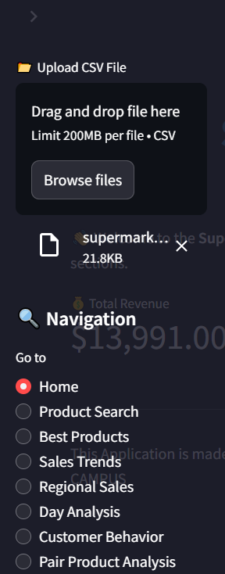

#### Home



Figure ; Home

#### Top products selling

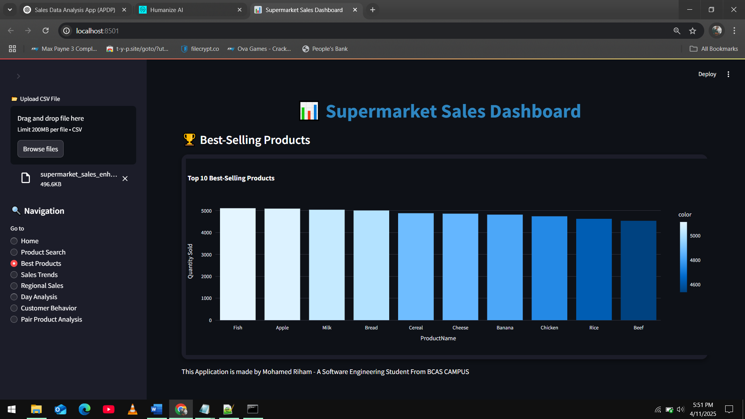

Figure ; Top Selling Products

#### Monthly sales trends

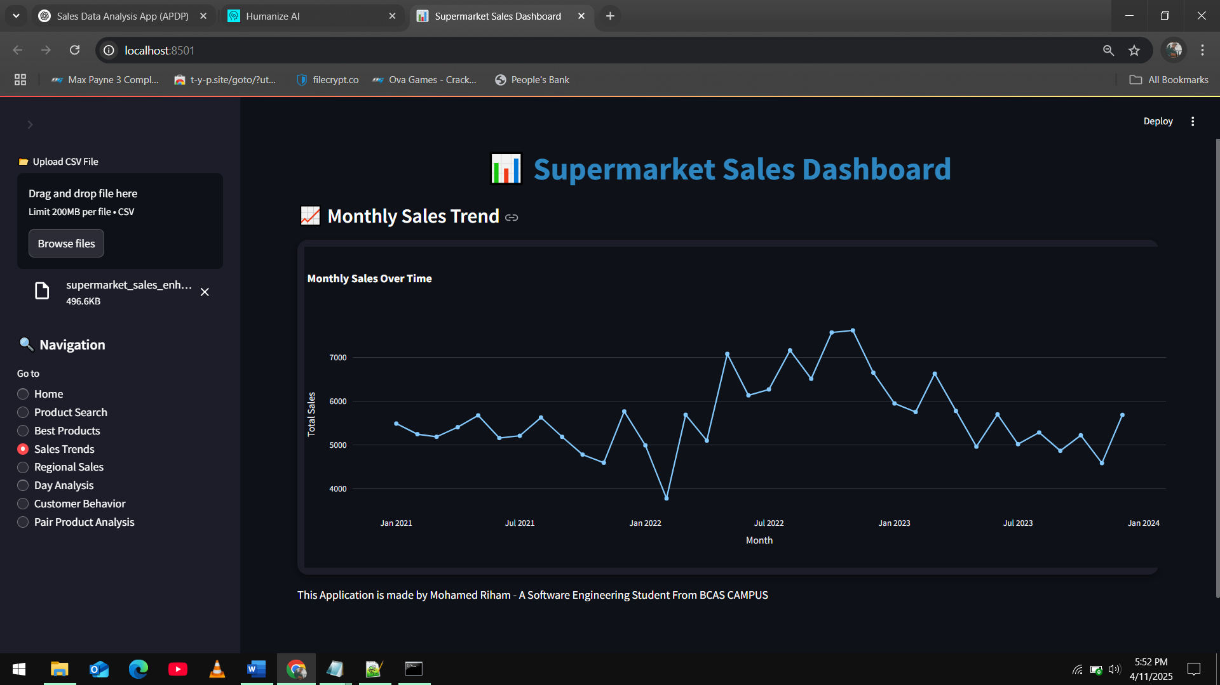

Figure ; Monthly Sales Trend

#### Regional performance

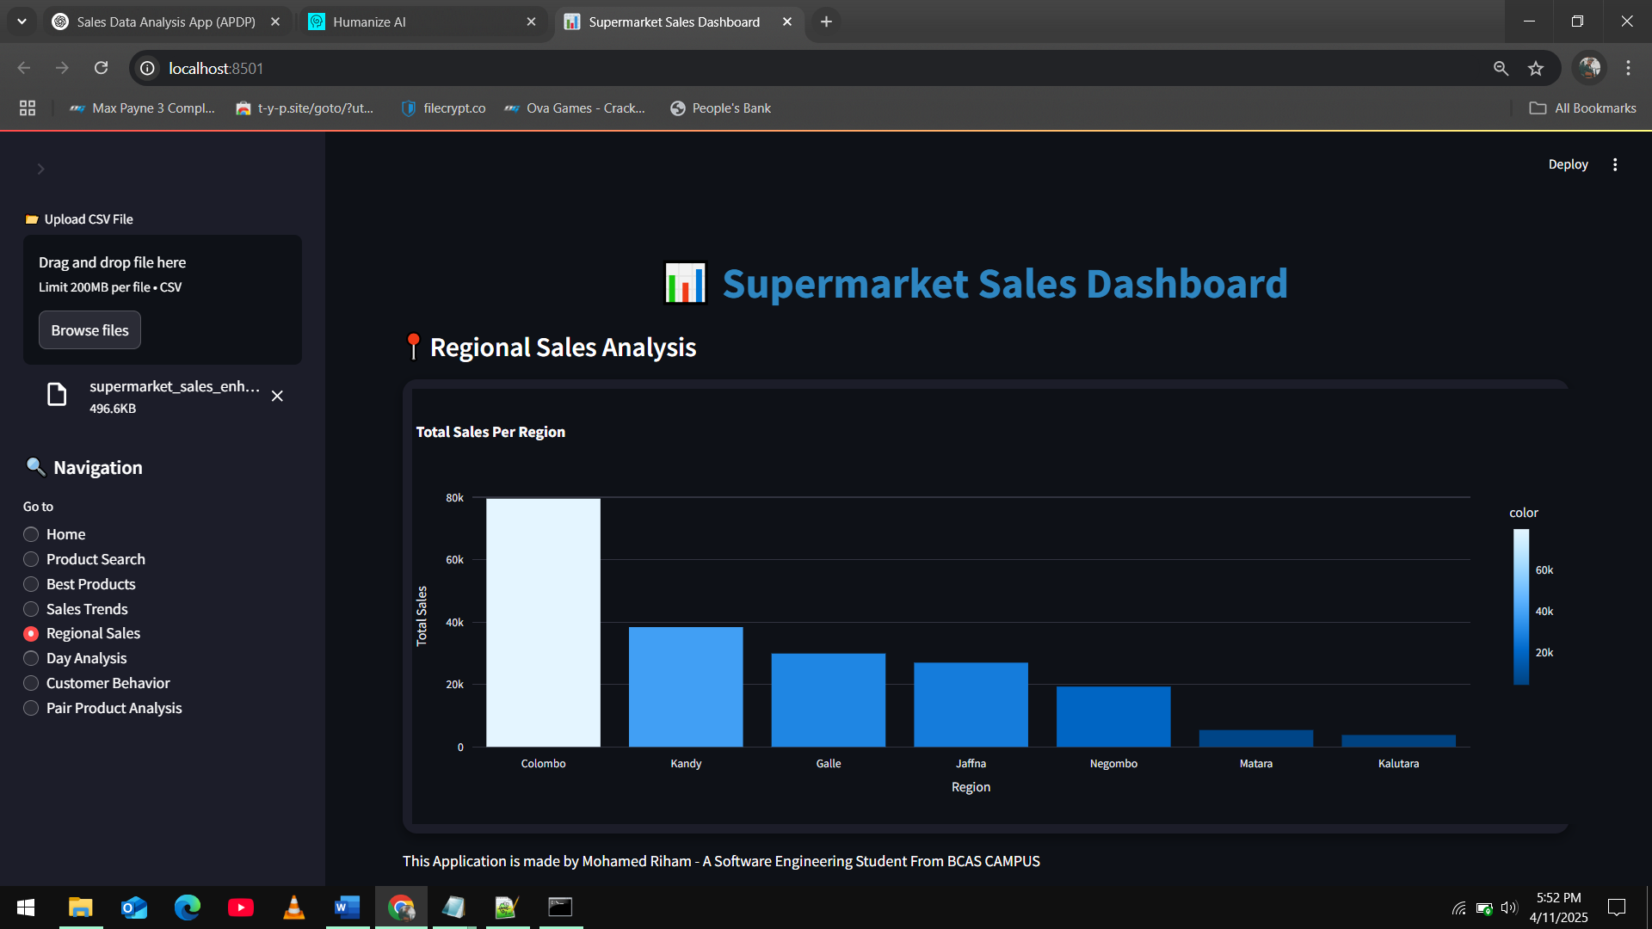

Figure ; Regional Sales Analysis

#### Customer behaviour analysis

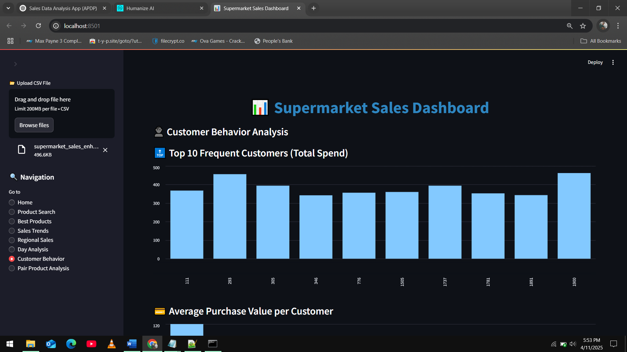

Figure ; Top 10 Frequent Customer (Total Spend)

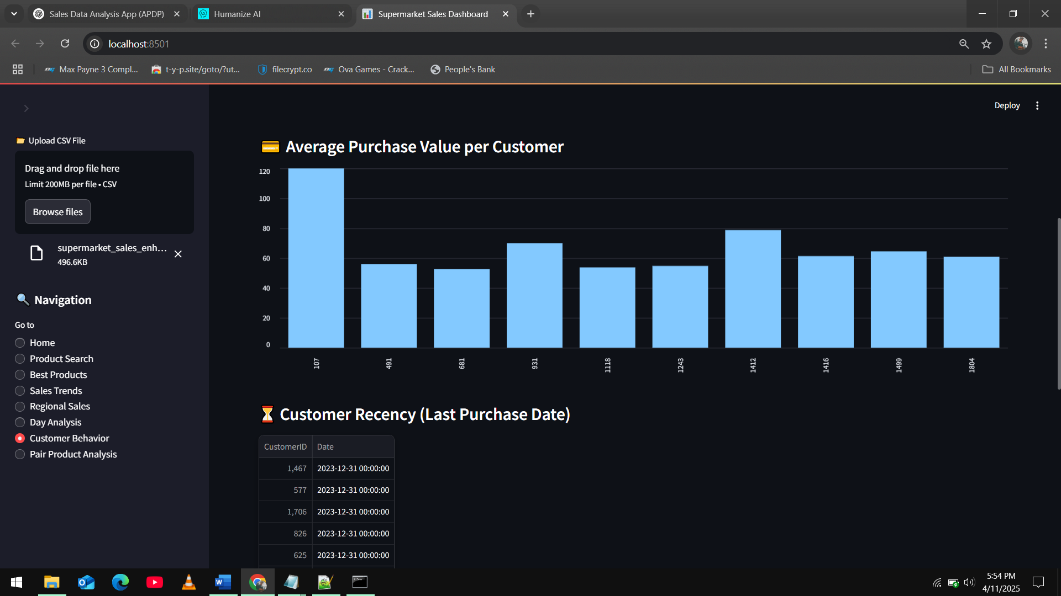

Figure ; Average Purchase Value per Customer

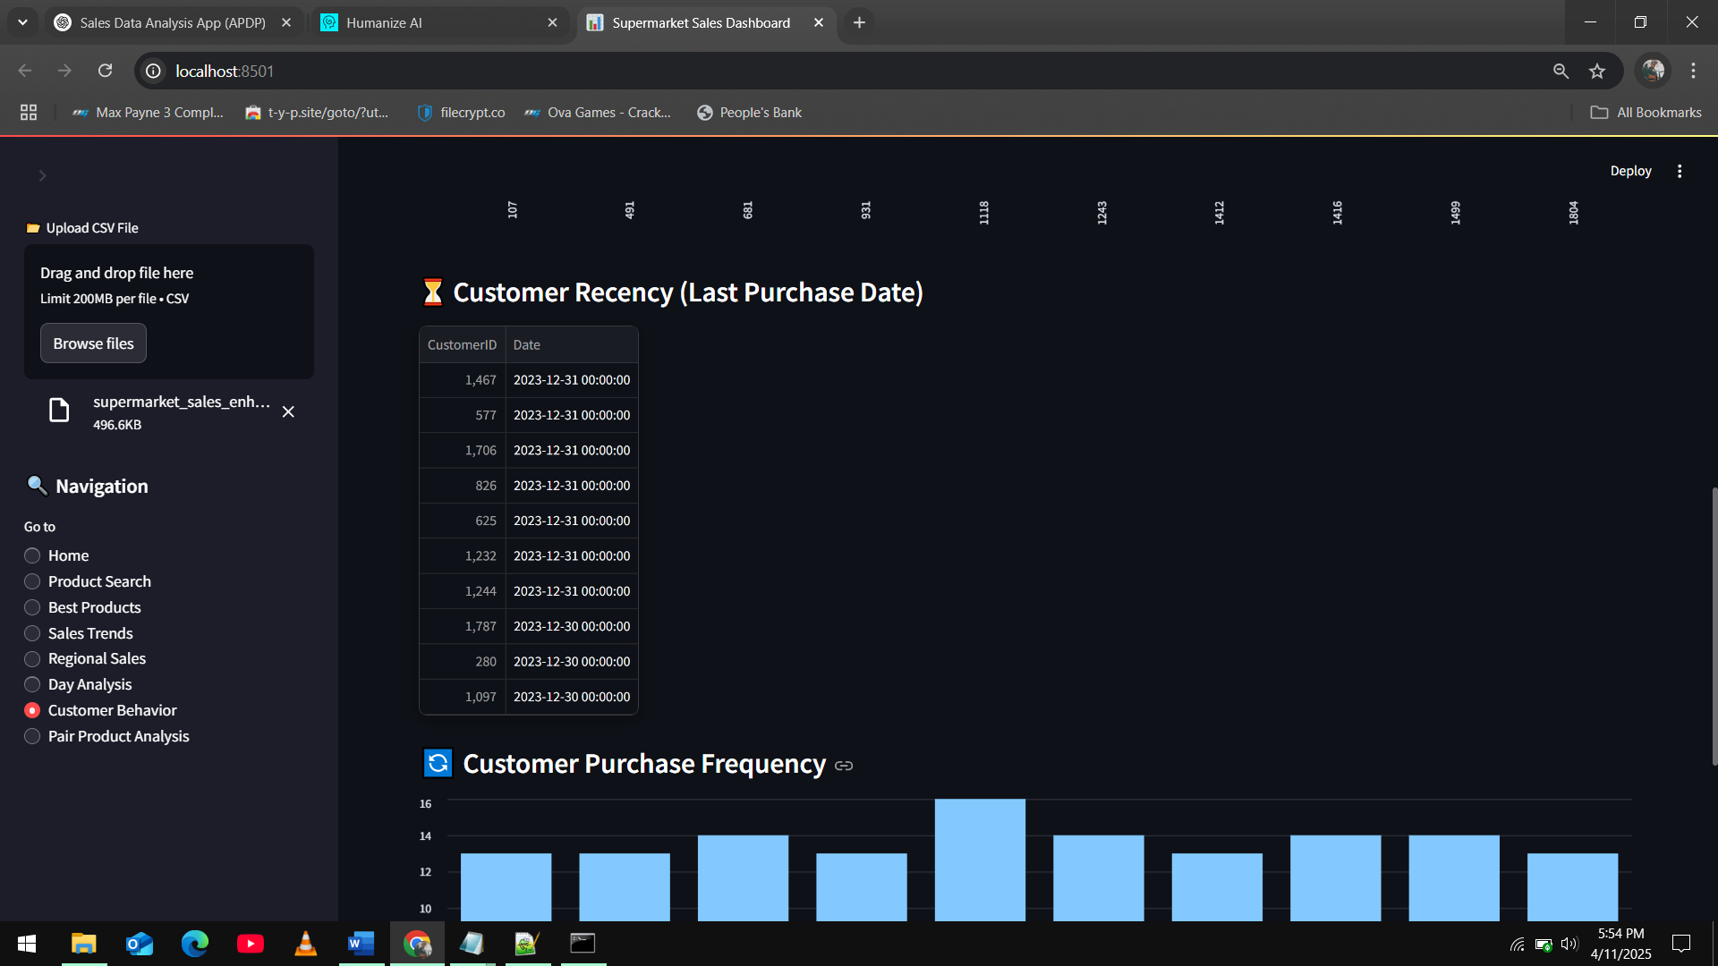

Figure ; Customer Recency (Last Purchase Date)

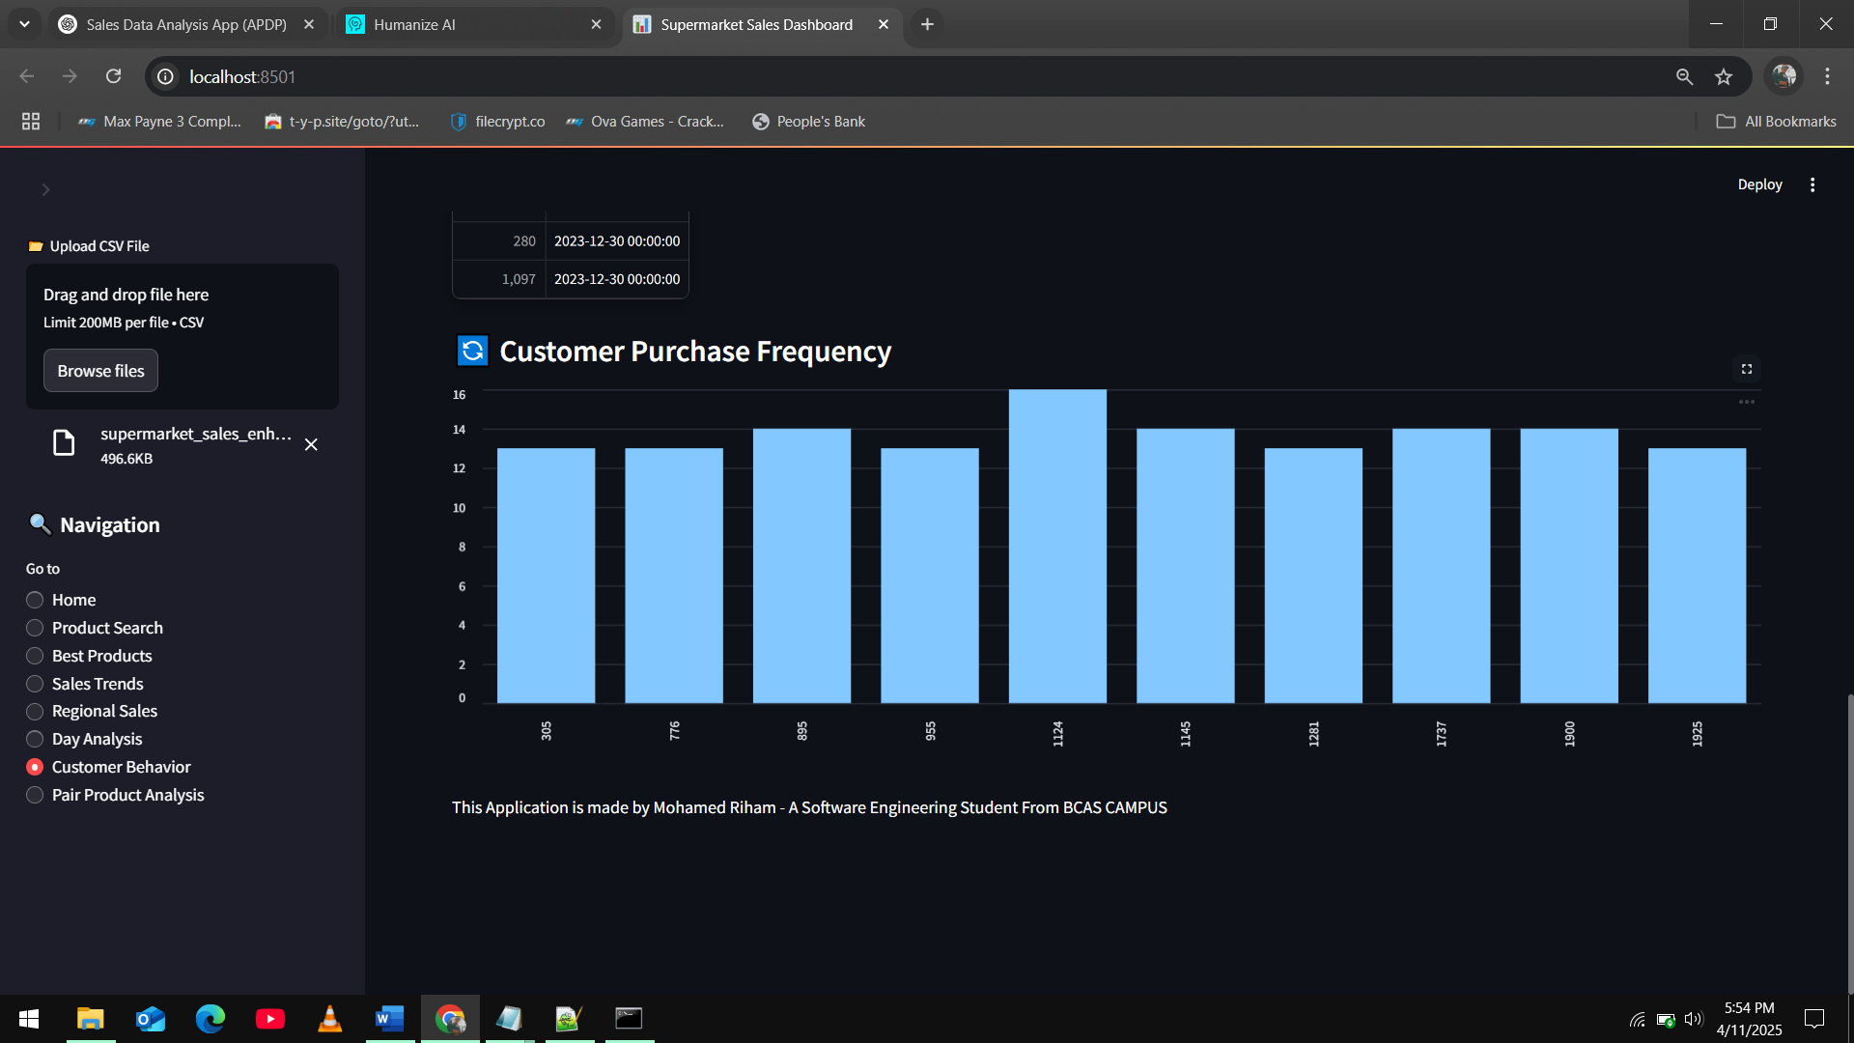

Figure ;Customer Purchase Frequency

#### Product search with sales

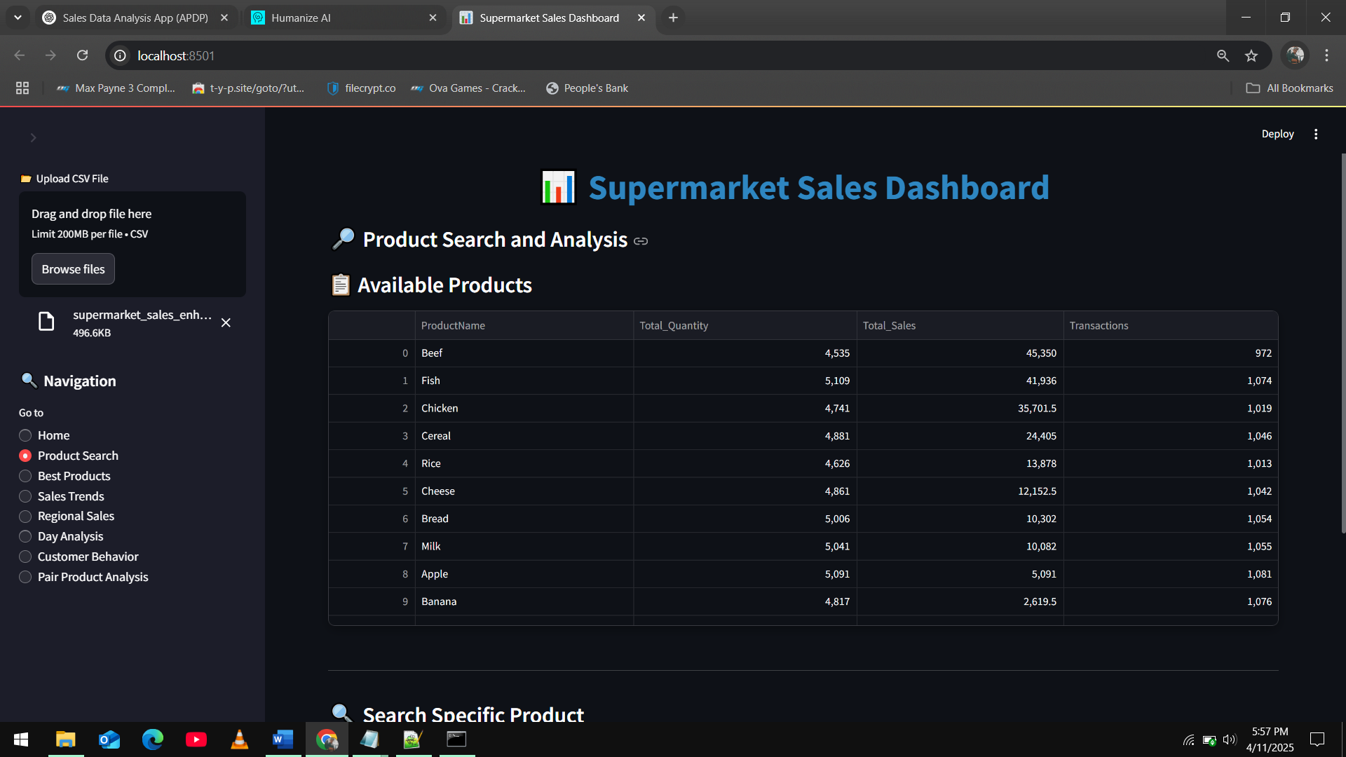

Figure ; Pruduct Search - Available Products

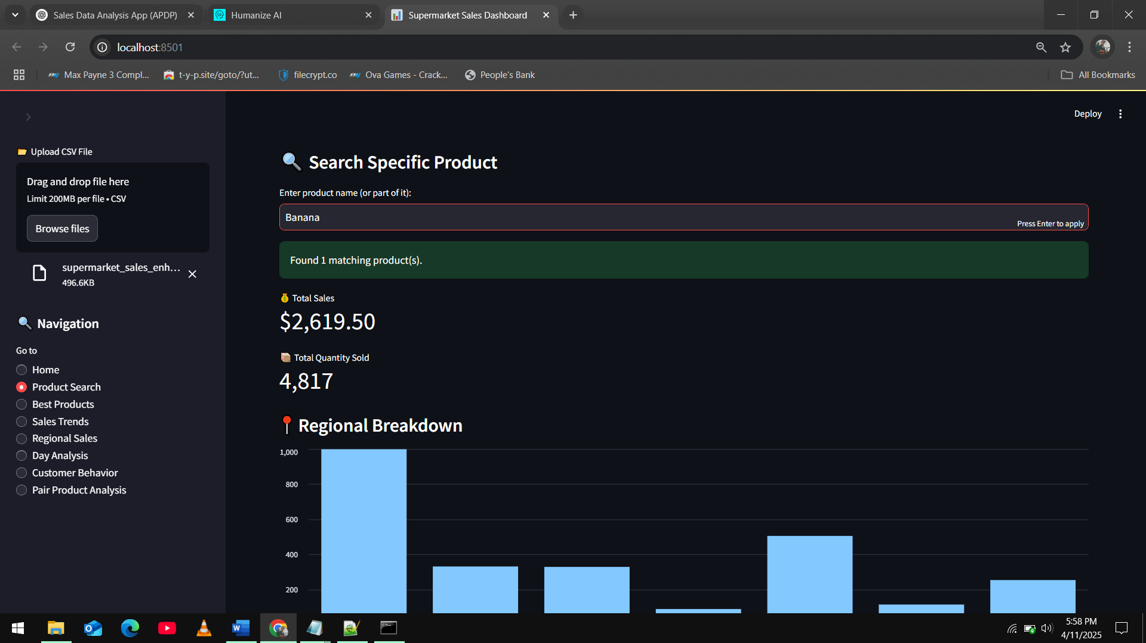

Figure ; Search Specific Product

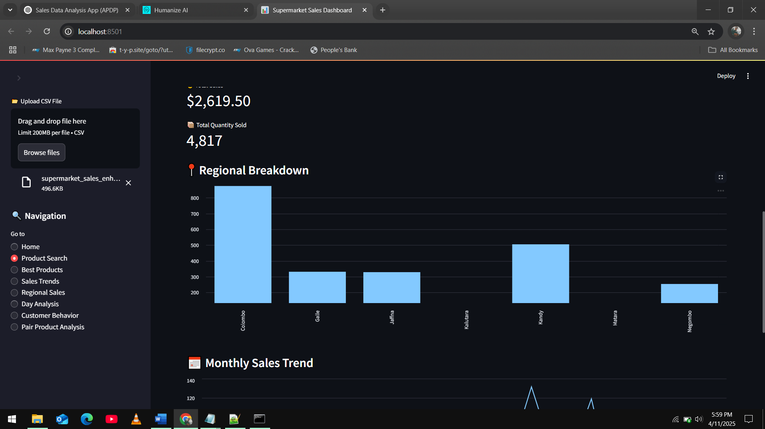

Figure ; Regional Breakdown of the searched product

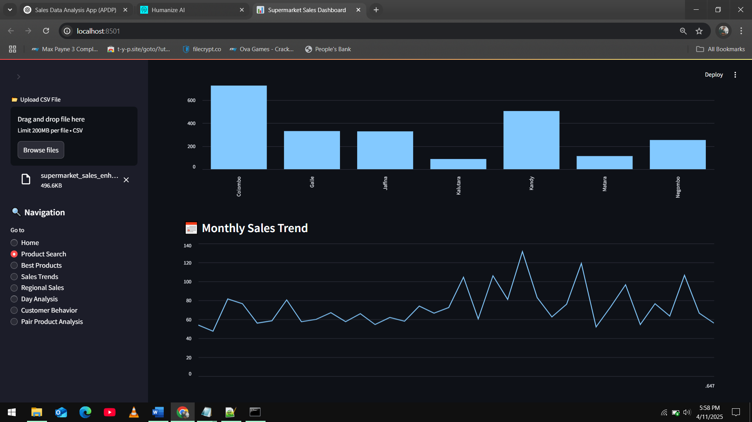

Figure ; sales trend of searched product

#### Pair product analysis

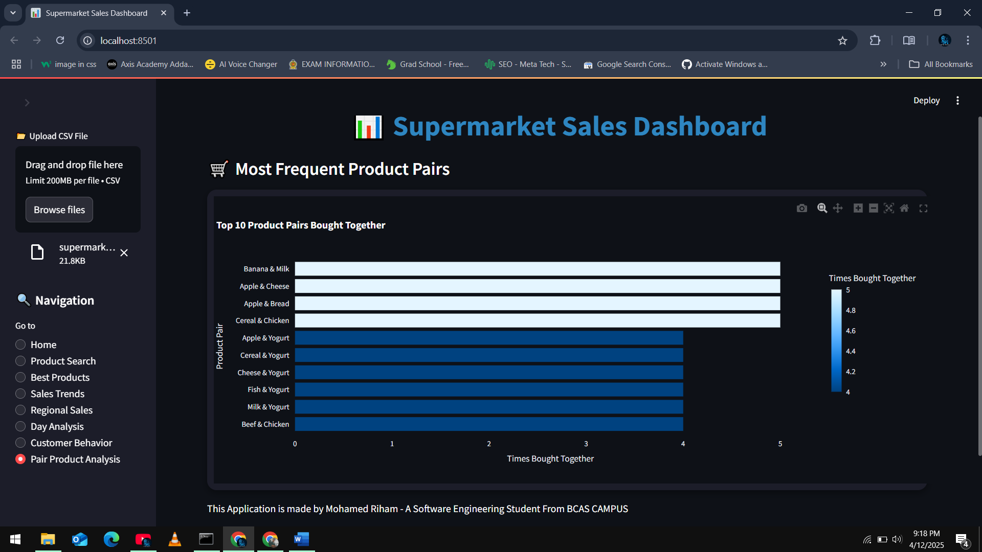

Figure ; pair product analysis

The architecture consists of a modular design, segregating concerns for data ingestion, processing, analysis, storage, and UI presentation.

## Development of the Python-Based Sales Analysis App

The app was developed with Streamlit and Python to process supermarket sales data. Although it was initially proposed as a Command-Line Interface (CLI), the Graphical User Interface (GUI) was applied with Streamlit for greater interactivity and visualization.

The main modules of the system are:

#### DataIngestionModule: Ingests data using the Factory Pattern.

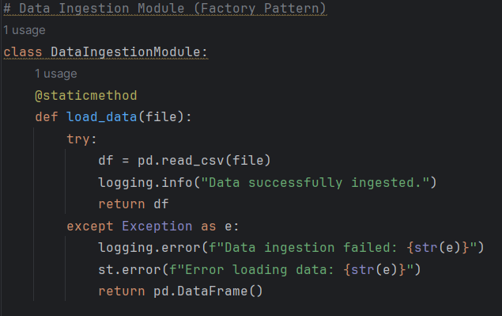

Figure ; Data Ingesion Module

#### DataProcessingModule: Cleans, transforms, and prepares the data.

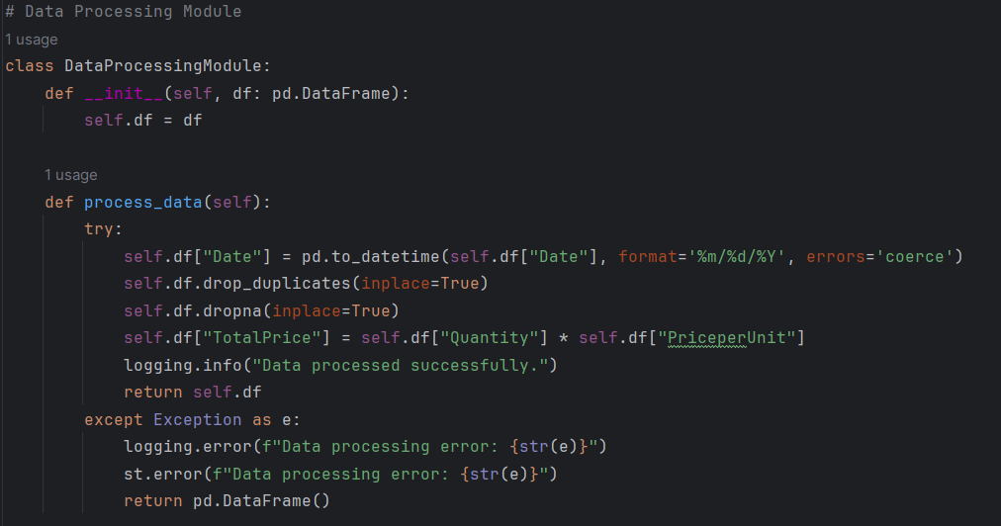

Figure ; Data Processing Module

#### DataStorageModule: Makes use of the Singleton Pattern for storing a single instance of the data.

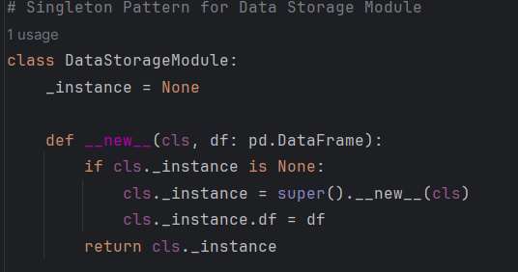

Figure ; Data Storage Module

#### DataAnalysisModule: Employs the Observer Pattern to dynamically examine data.

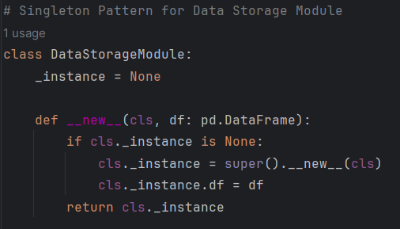

Figure ; Data Storage Module

#### UserInterfaceModule: Displays results in interactive graphs and charts using Plotly and Streamlit.

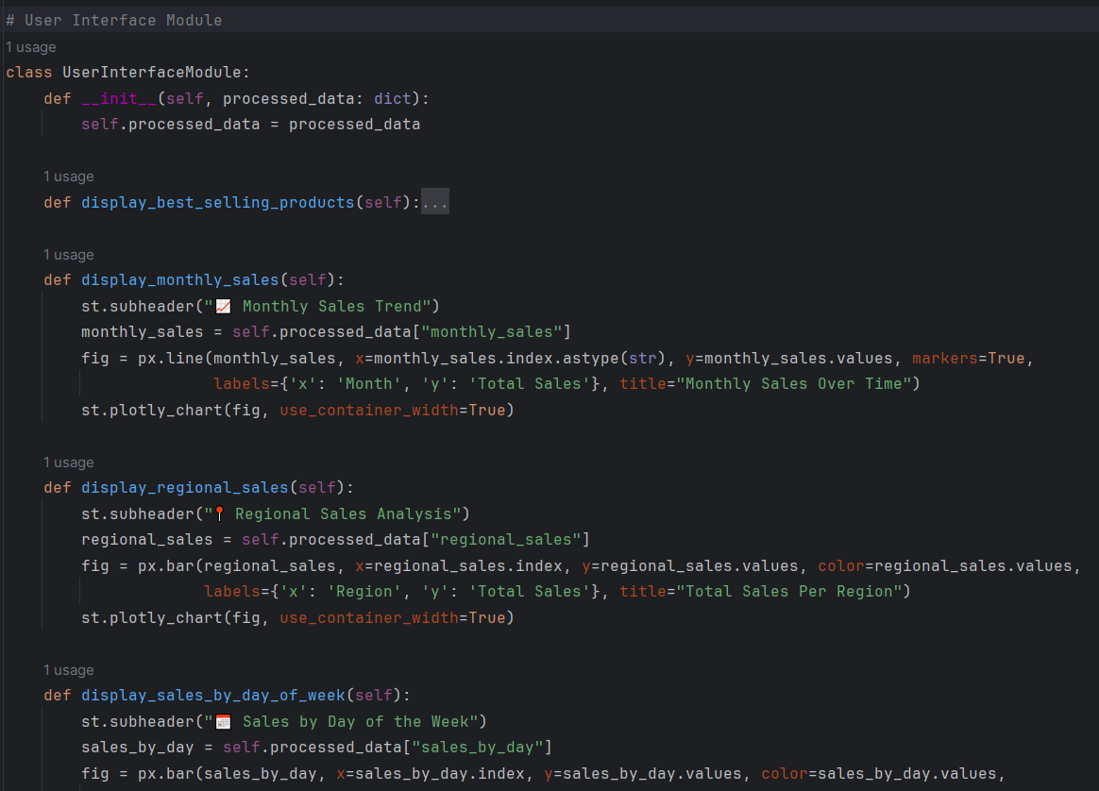

Figure ; user interface module 1

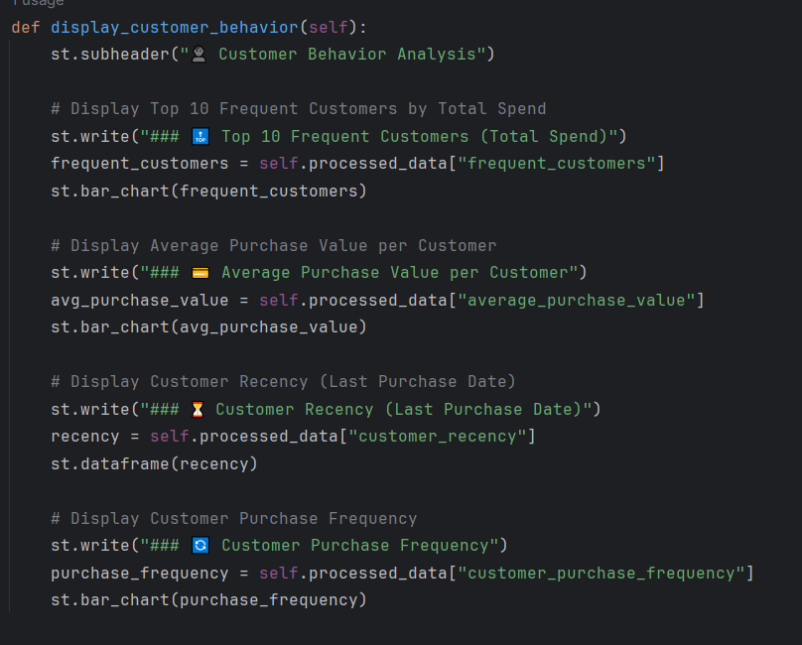

Figure ; user interface module 2

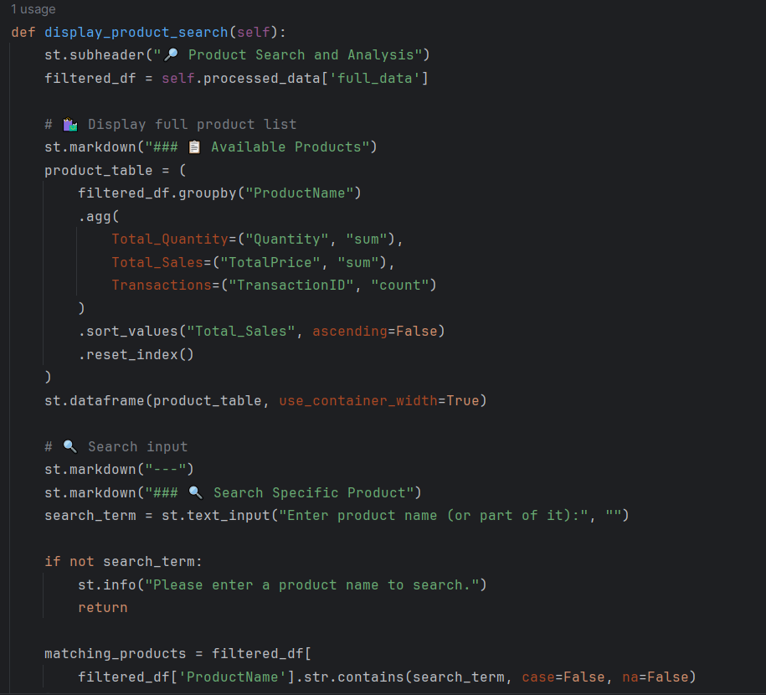

Figure ; user interface module 3

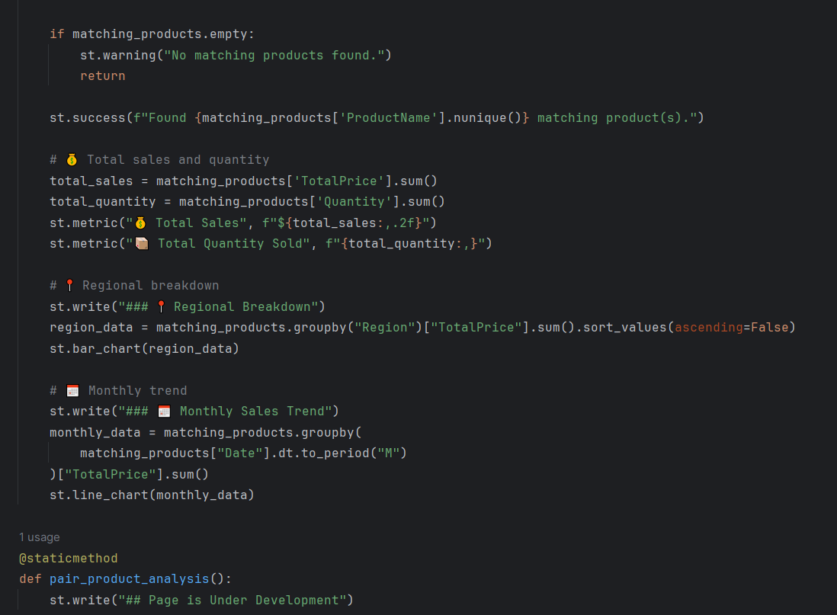

Figure ; user interface module 4

## Assessment of SOLID Principles, Clean Code Practices, and Design Patterns

#### Application of SOLID Principles

Table ; applied solid principle

|  |  |  |  |
| --- | --- | --- | --- |
| ****Principle**** | **Explanation** | **Application in Project** | **Assessment** |
| ****S – Single Responsibility Principle**** | A class should have only one reason to change. | Each module (e.g., DataProcessingModule, UserInterfaceModule) is focused on a single responsibility. | Well applied |
| ****O – Open/Closed Principle**** | Software entities should be open for extension but closed for modification. | Modular design allows the addition of new features (e.g., analysis pages) without altering existing logic. | Well applied |
| ****L – Liskov Substitution Principle**** | Subtypes must be substitutable for their base types. | Observer pattern is implemented using a base class, allowing safe substitution. | Properly applied |
| ****I – Interface Segregation Principle**** | Clients should not be forced to depend on unused methods. | Functional segregation ensures each module only implements required methods. | Applied correctly |
| ****D – Dependency Inversion Principle**** | Depend on abstractions, not on concretions. | System flow is modular | Applied Correctly |

#### Clean Code Practices

Table ; Clean code practices

|  |  |  |  |
| --- | --- | --- | --- |
| ****Practice**** | **Description** | **Application in Project** | **Assessment** |
| ****Meaningful Naming**** | **Names should be self-explanatory and descriptive.** | **Functions like display_best_selling_products and process_data are clearly named.** | **Excellent** |
| ****Modularity**** | **Code should be divided into reusable and focused units.** | **Functions are logically separated and grouped into purpose-driven modules.** | **Well implemented** |
| ****Error Handling**** | **Anticipate and manage runtime errors.** | **Uses try-except blocks in critical areas like data ingestion and processing.** | **Handled properly** |
| ****Logging**** | **Use of loggers instead of print statements for debugging and feedback.** | **Logging is implemented to track system flow and errors.** | **Good practice** |
| ****Documentation**** | **Use of comments and docstrings for clarity.** | **Most analysis methods contain helpful docstrings.** | **Applied; could be expanded** |
| ****Avoiding Duplication**** | **Duplicate code should be minimized.** | **Reusable functions are created for repetitive tasks.** | **Efficient design** |

#### Use of Design Patterns

Table ; Use of design patterns

|  |  |  |
| --- | --- | --- |
| ****Design Pattern**** | ****Usage in Project**** | ****Assessment**** |
| ****Factory Pattern**** | **Used in data ingestion to create and return processed DataFrames.** | **Appropriately used** |
| ****Singleton Pattern**** | **Implemented in DataStorageModule to maintain a consistent shared state.** | **Well implemented** |
| ****Observer Pattern**** | **DataAnalysisModule receives data updates through the update() method.** | **Functional and extendable** |
| ****MVC-like Architecture**** | **The system separates logic (Controller), UI (View), and data (Model).** | **Promotes maintainability and scalability** |
| ****Extensibility Patterns**** | **Code structured to support future enhancements (e.g., charts, reports).** | **Can benefit from strategy or adapter patterns for more flexibility** |

### **Clean Code Practices**

###### **Meaningful Class & Function Names** (e.g., display_best_selling_products)



Figure ; meaning full names

###### **Logging Instead of Print Statements: Maintains professional debugging flow**



Figure ; Logging

###### **Error Handling: Ensures that users are informed of issues gracefully**

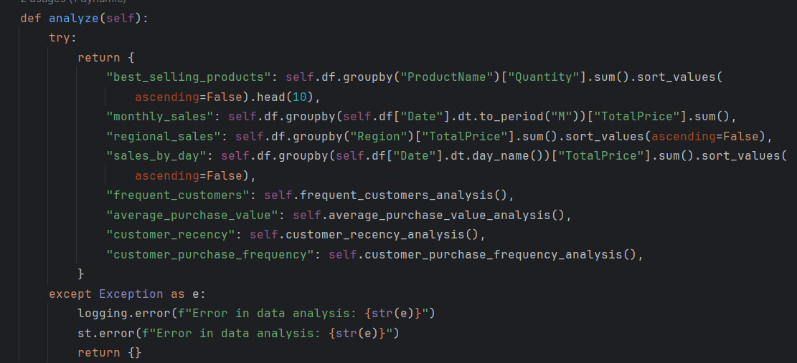

Figure ; using try - except

###### **Comments and Docstrings: Improve readability and maintainability**



Figure ; comment



Figure ; comment



Figure ; comment;



Figure ; docstring



Figure ; docstring

###### **Modular Codebase: class/function has a clear purpose**

* Everything has its own purpose

#### Conclusion

This project illustrates the power of clean architecture, design patterns, and the SOLID principles. The result is a scalable, maintainable, interactive sales dashboard application that is capable of delivering actionable insights. Originally envisioned as a CLI, the addition of Streamlit enhanced the usability and presentation, making it more plausible for real users.

# Part 04: Automated Testing & Report

## Objective:

The objective of this section is to design and perform different levels of testing for the Sales Dashboard application. These tests ensure the system to be stable, meet the specifications required, and operate smoothly under various scenarios. The testing types include Unit Testing, Integration Testing, System Testing, and User Acceptance Testing (UAT).

## Test Implementation:

### Setup:

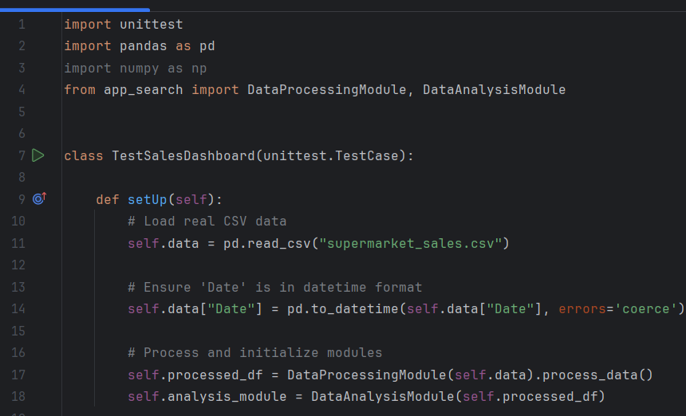

Figure ; Test Setup

### Unit Test Development:

Unit tests are developed to test individual parts of the system separately to ensure that each part is functioning properly. Unit tests are about the correctness of the smallest unit in the system, which are usually functions or methods.

**Unit Test Goals:**

* + Ensure single functions and methods are correct.
  + Verify correct edge cases and unknown inputs handling.
  + Ensure data transformations and calculations.

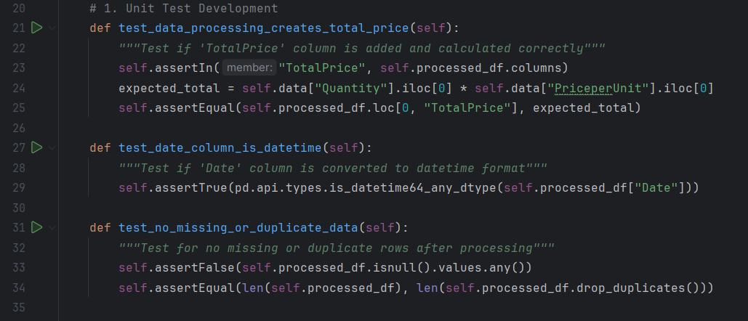

Figure ; Unit Test

### Integration Testing:

Integration tests aim at whether different pieces or modules of the system are compatible with one another. Integration testing determines whether the system modules behave as expected when combined.

**Integration Test Objectives:**

* + Ensure that different parts of the system (e.g., data processing and analysis) integrate seamlessly.
  + Ensure that data flows seamlessly between modules and their outputs match the expected behaviour.

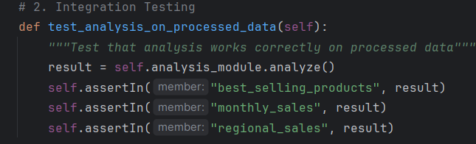

Figure ; Integration Testing

### System Testing:

System testing is performed on the entire system as a system. It confirms that the system meets the requirements specified in the design documents and that the components work together to meet the overall system requirements.

**System Test Objectives:**

* + Confirm that the entire system meets user requirements.
  + Ensure all the functionality works together as desired.
  + Test real-world usage scenarios and confirm the system's performance.

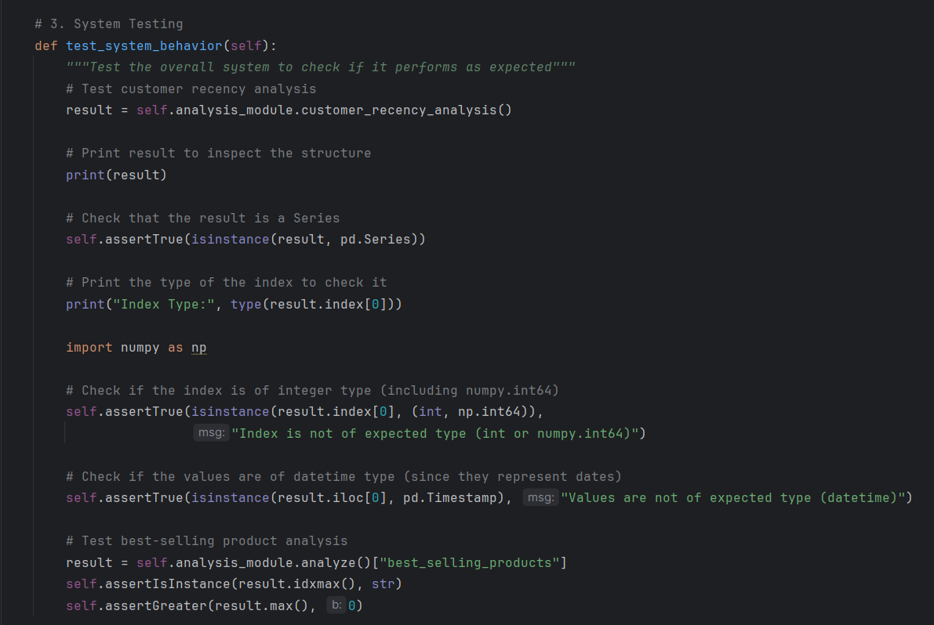

Figure ; System testing

### User Acceptance Testing (UAT):

User Acceptance Testing (UAT) is the process of testing the system in a real or simulated environment by the end-users. UAT ensures that the system is as per the business requirements and that the users can effectively use the system for its intended purpose.

**UAT Objectives:**

* + Ensure that the system is as per the business requirements.
  + Ensure that the system is user-friendly and usable by end-users.
  + Determine any issues that could arise when the system is deployed in a live environment.

This testing uses User Interface because its used by end users so we need to test them in user perspective so I integrated the streamlit interface to test that.

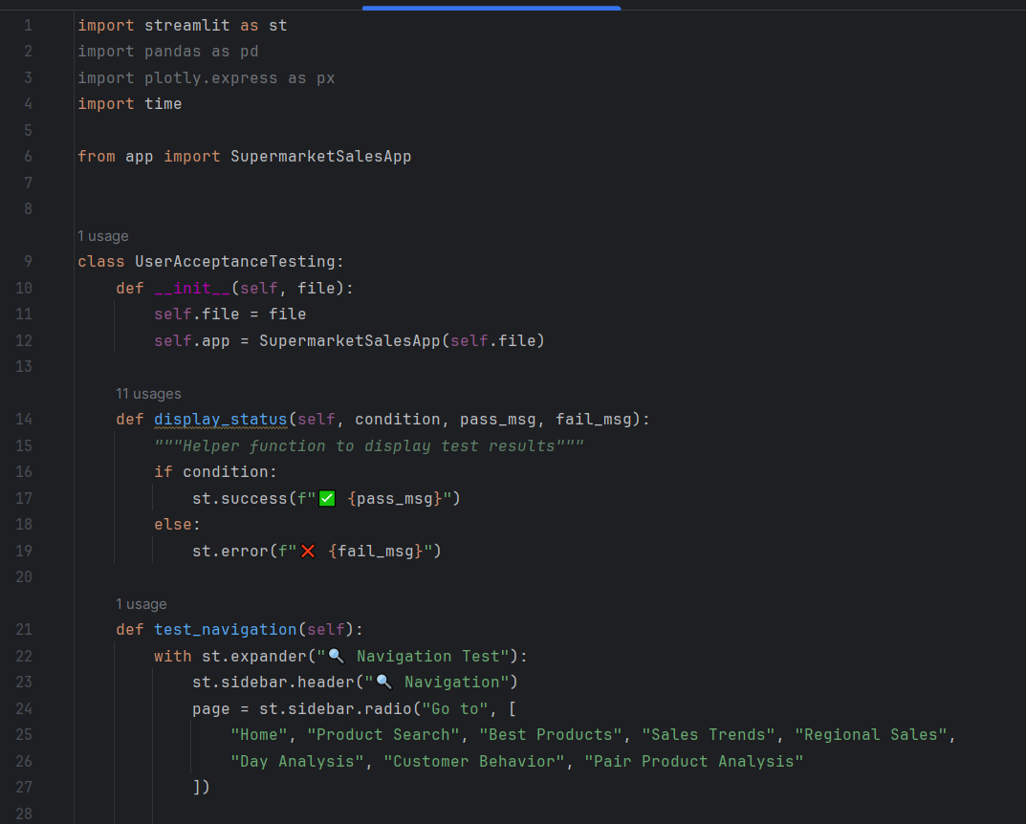

Figure ; UAT Testing

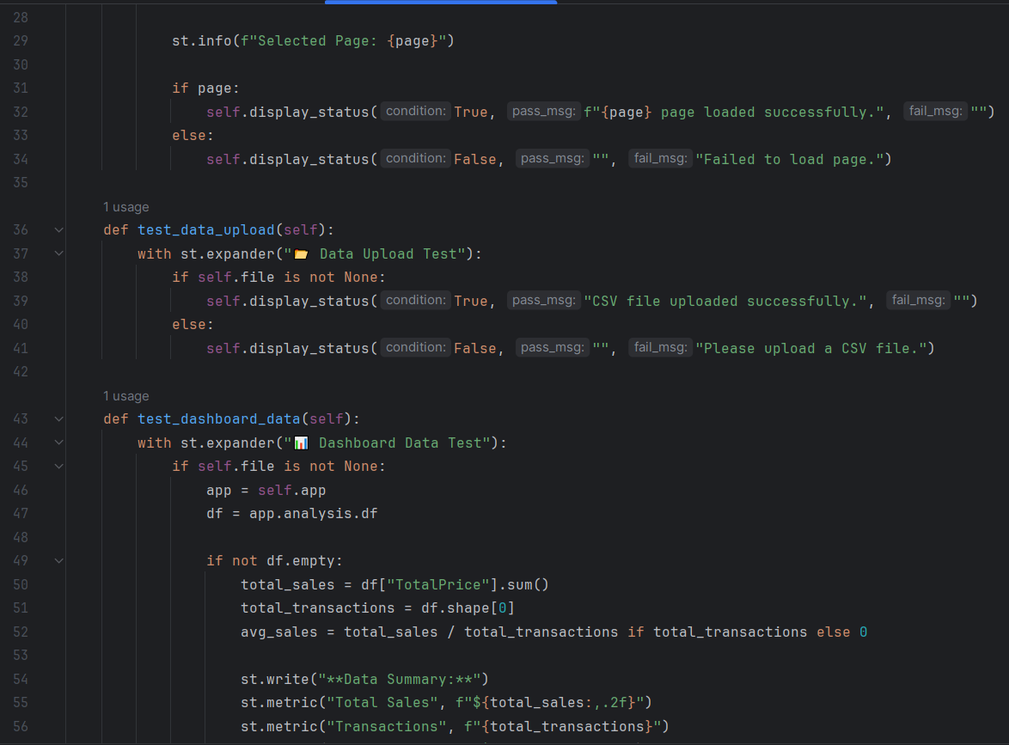

Figure ; UAT2

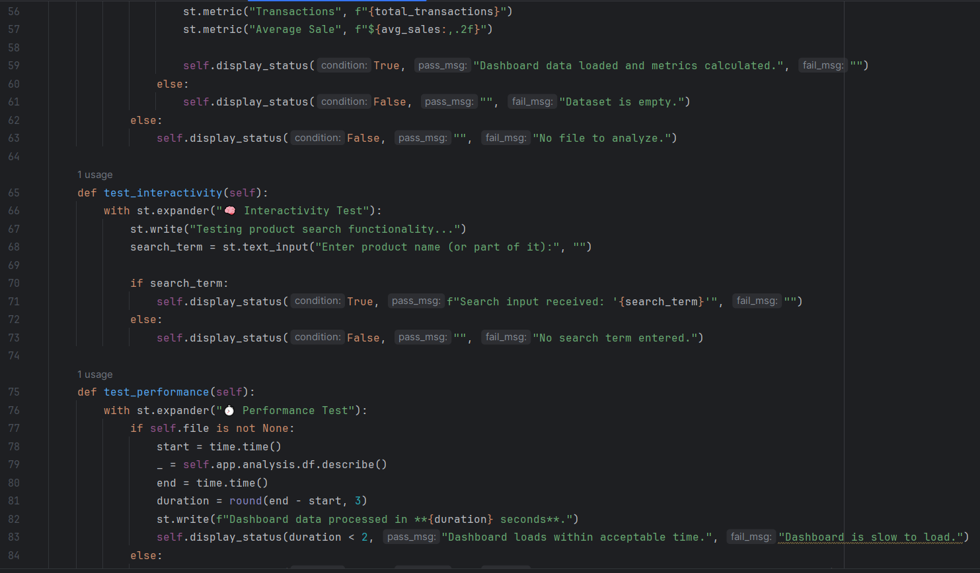

Figure ; UAT3

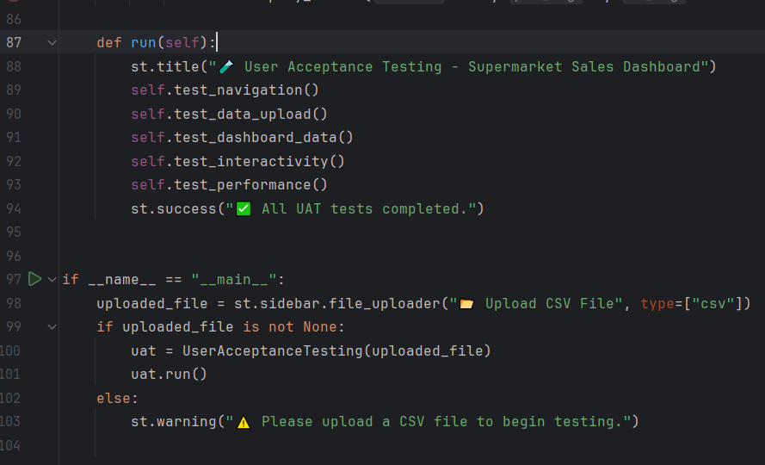

Figure ; UAT4

## Test Results

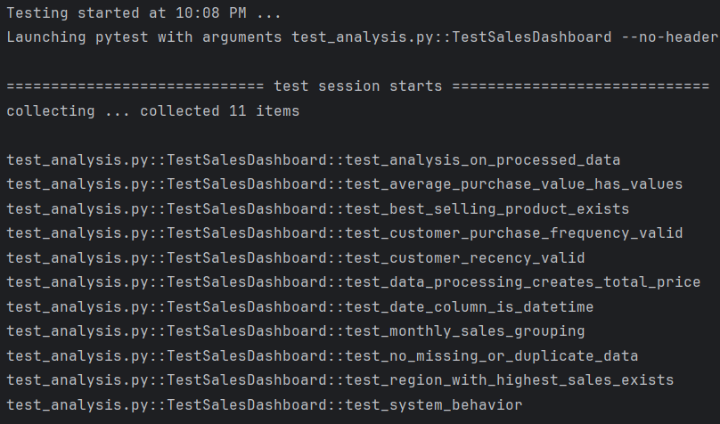

Figure ; Test Results



Figure ; Test 100% Success

### Unit Test Results:

Each unit test for individual components, such as data processing and column calculation, was successful. This is to ensure that the smallest components of the application are working seamlessly.

### Integration Test Results:

Integration tests also passed, confirming that the data flows seamlessly from one module to another. For example, the analysis functions work flawlessly when used on processed data.

### System Test Results:

System tests were successful, ensuring that the application meets general requirements, handles different data inputs, and acts appropriately in real-world scenarios. Changes were made to index type handling to accommodate the data structure, resolving earlier test failures.

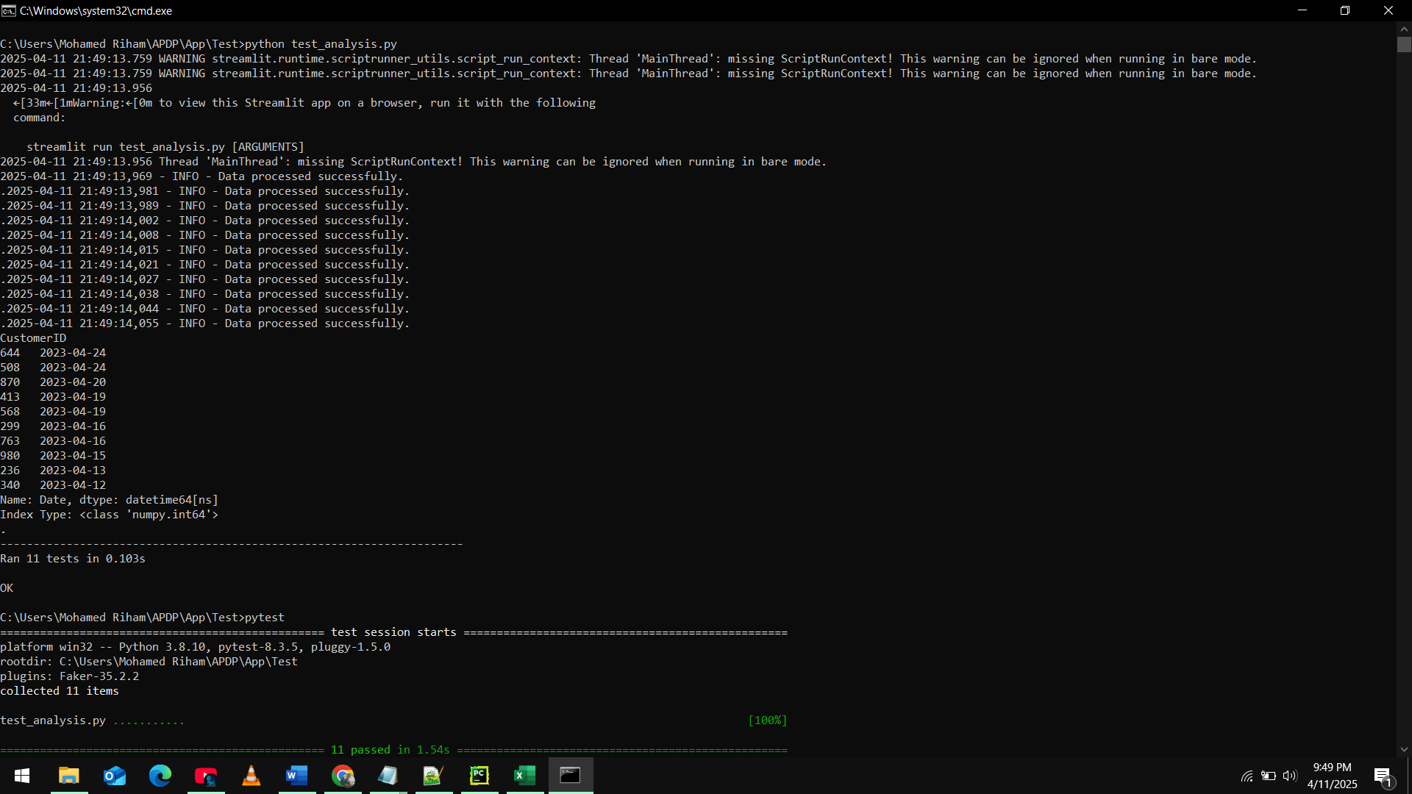

Figure ; CMD View of Test Results

I have combined 3 testing (unit test, integration test, system test) in one file, all tests ran successfully without errors, but the error showing in the top is not the error. It’s a warning sign that shows to use Streamlit but we don’t need them for this 3 testing.

### User Acceptance Testing (UAT):

End users will have to glance through the application based on their needs. Development team feedback is initial, and based on them, the application seems intuitive and performs well. Actual final testing will, however, be carried out by real end-users.

For this user acceptance testing I have integrated UI based testing because it has to be.

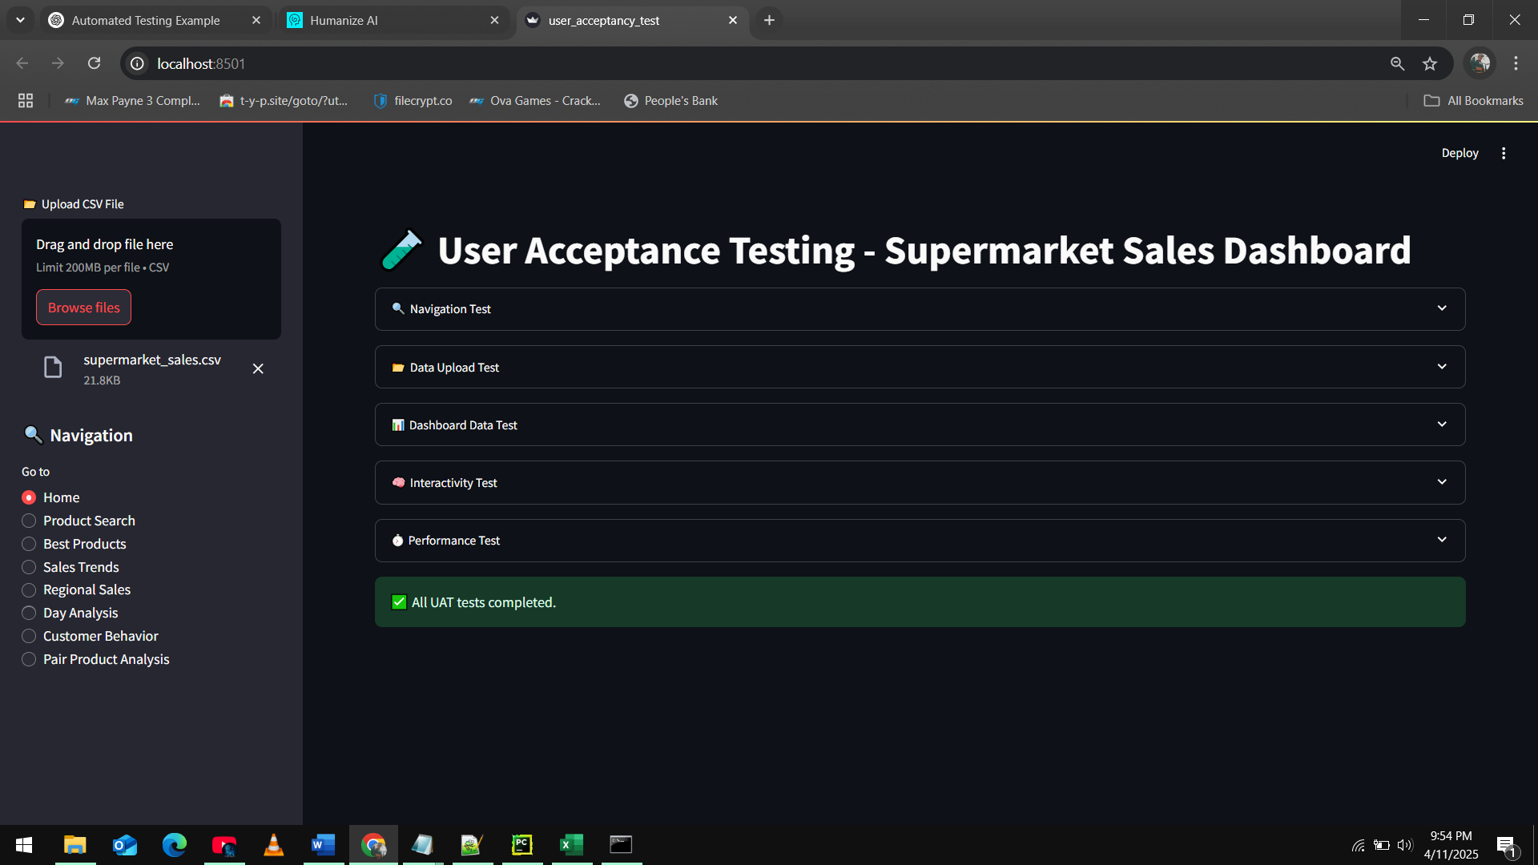

Figure ; User Acceptance Testing

##### Navigation Test:

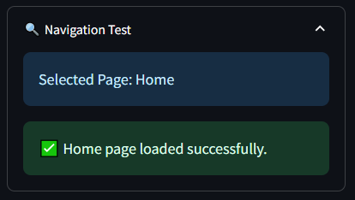

Figure ; Navigation Test

In navigation testing, all pages are loading successfully.

##### Data Upload Test:

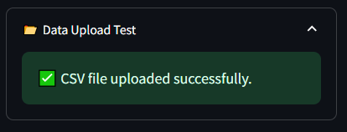

Figure ; Upload CSV test

Application is correctly loading the csv file.

##### Dashboard Data Test:

It shows the correct details.



Figure ; Data fetch Test

##### Interactivity Testing (Search Function):

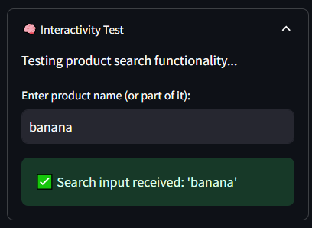

Figure ;Search function test

Search Function working very well.

##### Performance Testing:

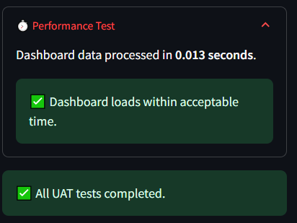

Figure ; Performance Testing

The performance of the application is very fast.

##### Conclusion

The Sales Dashboard application is fully tested, including Unit Tests, Integration Tests, System Testing, and User Acceptance Testing (UAT).

* **Unit Tests**: Ensured individual components work as expected.
* **Integration Tests**: Confirmed components interact correctly with one another.
* **System Tests**: Ensured the entire system meets specified requirements.
* **User Acceptance Testing (UAT)**: Tested by an user and it went very well

The application is solid and stable, and UAT feedback is very useful. Automated testing has helped to catch issues early and verify that the application functions correctly at different levels.

# References

Anon., 2013. *Wikipedia.* [Online]   
Available at: https://en.wikipedia.org/wiki/Design_Patterns  
[Accessed 28 03 2025].

Anon., 2024. *Geeks For Geeks.* [Online]   
Available at: https://www.geeksforgeeks.org/creational-design-pattern/  
[Accessed 28 03 2025].

Anon., 2024. *Geeks For Geeks.* [Online]   
Available at: https://www.geeksforgeeks.org/tips-to-write-clean-and-better-code/  
[Accessed 28 03 2025].

Anon., 2024. *GeeksforGeeks.* [Online]   
Available at: https://www.geeksforgeeks.org/abstract-classes-in-python/  
[Accessed 11 03 2025].

Anon., 2024. *GeeksforGeeks.* [Online]   
Available at: https://www.geeksforgeeks.org/association-composition-aggregation-java/  
[Accessed 11 03 2025].

Anon., 2024. *StackOverFlow.* [Online]   
Available at: https://stackoverflow.com/questions/78431629/how-to-match-the-student-to-his-own-teacher  
[Accessed 11 03 2025].

Anon., 2025. *Geeks For Geeks.* [Online]   
Available at: https://www.geeksforgeeks.org/introduction-to-pattern-designing/  
[Accessed 28 03 2025].

Anon., 2025. *Geeks For Geeks.* [Online]   
Available at: https://www.geeksforgeeks.org/solid-principle-in-programming-understand-with-real-life-examples/  
[Accessed 28 03 2025].

Anon., 2025. *Geeks For Geeks.* [Online]   
Available at: https://www.geeksforgeeks.org/singleton-design-pattern/  
[Accessed 28 03 2028].

Anon., 2025. *Geeks For Geeks.* [Online]   
Available at: https://www.geeksforgeeks.org/observer-pattern-set-1-introduction/  
[Accessed 28 03 2028].

Anon., 2025. *W3Resource.* [Online]   
Available at: https://www.w3resource.com/java-exercises/java-inheritance-exercise-5.php  
[Accessed 11 03 2025].

Anon., 2025. *W3Resources.* [Online]   
Available at: https://www.w3resource.com/java-exercises/oop/java-oop-exercise-21.php  
[Accessed 11 03 2025].

Anon., 2025. *W3Resources.* [Online]   
Available at: https://www.w3resource.com/java-exercises/java-polymorphism-exercise-2.php  
[Accessed 11 03 2025].

Anon., 2025. *Wikipedia.* [Online]   
Available at: https://en.wikipedia.org/wiki/SOLID  
[Accessed 28 03 2025].

Anon., n.d. *StackOverFlow.* [Online]   
Available at: https://stackoverflow.com/questions/885937/what-is-the-difference-between-association-aggregation-and-composition  
[Accessed 11 03 2025].

Anon., n.d. *Wikipedia.* [Online]   
Available at: https://www.geeksforgeeks.org/solid-principle-in-programming-understand-with-real-life-examples/  
[Accessed 28 03 2025].

Chris, K., 2023. *FreeCodeCamp.* [Online]   
Available at: https://www.freecodecamp.org/news/open-closed-principle-solid-architecture-concept-explained/  
[Accessed 28 03 2025].

Christian, 2021. *Wiki.* [Online]   
Available at: http://principles-wiki.net/collections:robert_c._martin_s_principle_collection  
[Accessed 28 03 2025].

Ganglani, H., 2023. *Medium.* [Online]   
Available at: https://medium.com/%40himanshuganglani/clean-code-objects-and-data-structures-95f7265762dc  
[Accessed 28 03 2025].

Liskov, B., 2018. *Wikipedia.* [Online]   
Available at: https://en.wikipedia.org/wiki/Liskov_substitution_principle  
[Accessed 11 03 2025].

MARK, M., 2023. *Dev.* [Online]   
Available at: https://dev.to/favourmark05/writing-clean-code-best-practices-and-principles-3amh  
[Accessed 28 03 2025].

McBurney, P., n.d. *SDE.* [Online]   
Available at: https://sde-coursepack.github.io/modules/patterns/Design-Patterns/  
[Accessed 28 03 2028].

Oloruntoba, S. & Walia, A. S., 2024. *Digital Ocean.* [Online]   
Available at: https://www.digitalocean.com/community/conceptual-articles/s-o-l-i-d-the-first-five-principles-of-object-oriented-design  
[Accessed 28 03 2025].

Savvyprogrmr, 2023. *Reddit.* [Online]   
Available at: https://www.reddit.com/r/cleancode/comments/15erwmq/clean_code_guide_that_will_help_you_understand/  
[Accessed 28 03 2025].

Smith, Z., 2016. *Stack Over Flow.* [Online]   
Available at: https://stackoverflow.com/questions/13472904/difference-between-structural-design-pattern-and-behavioral-design-pattern  
[Accessed 28 03 2025].

TP, V., 2024. *Coderzone.* [Online]   
Available at: https://coderzon.com/the-importance-of-solid-principles-in-software-development/  
[Accessed 28 03 2025].

Tutorialspoint, n.d. [Online]   
Available at: https://www.tutorialspoint.com/design_pattern/factory_pattern.htm  
[Accessed 28 03 2028].